Stroboscopic Light Stimulation in Adults Reporting Depressive Symptoms: Safety, Tolerability, Feasibility, and Active-Comparator Development in a Staged Early-Phase Study
SUPPLEMENTARY MATERIAL

S1. Screening, Eligibility, and Safety Protocol

Exclusion Criteria
WP1
Age below 18. Positive response to any question on the 4SQ (Schwartzman et al., 2025). PHQ-9 score below the threshold for at least mild depressive symptoms (<5). Depressive symptomatology displaying a seasonal pattern. No current depressive symptoms, such as low mood or sadness, or no extended periods of low mood. Current treatment with antipsychotic drugs. Current use of supplements, herbs, or medications for an insufficient period to establish familiarity. History of or current substance or drug misuse. History of or current diagnosis of psychosis, bipolar disorder, Parkinson's disease, dementia, or Alzheimer's disease. History of traumatic brain injury (TBI). Presence of eye disorders including retinal blindness, cataracts, retinal disease or glaucoma. Regular use of light therapy.
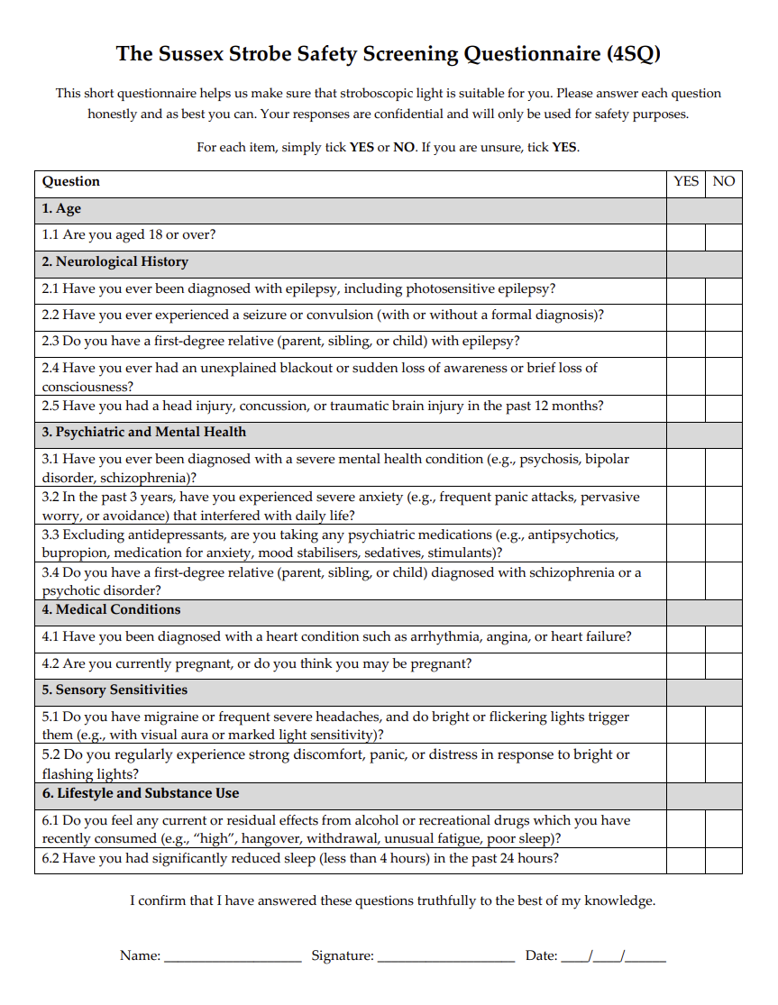
Figure S1. Sussex Strobe Safety Screening Questionnaire (4SQ). The 4SQ was used as the structured safety screen before any in-person stroboscopic light stimulation (SLS) exposure in WP1, the interim bridge study, and WP2. The questionnaire identifies potential contraindications or risk factors relevant to closed-eye flickering-light exposure, including age under 18, epilepsy or seizure history, recent head injury, severe psychiatric history, relevant medication use, medical conditions, pregnancy, sensory sensitivity to bright or flickering light, recent substance effects, and acute sleep deprivation. In this study, participants completed the 4SQ during pre-screening. A YES response, or uncertainty requiring a YES response, triggered exclusion from SLS exposure or further eligibility review according to the stage-specific screening workflow. Its purpose was to reduce avoidable risk before supervised SLS sessions and to ensure that all participants entering WP1, the interim bridge study, and WP2 had passed the same core stroboscopic-safety screen. For further detail on the rationale, safety domains, and practical use of the 4SQ, see Schwartzman et al. (2025).
Interim Study
Age below 18. Positive response to any question on the 4SQ (Schwartzman et al., 2025). STAI-Trait score above the implemented severe-anxiety exclusion threshold (>60). Current treatment with antipsychotic drugs. Current use of supplements, herbs, or medications for an insufficient period to establish familiarity. History of or current substance or drug misuse. History of or current diagnosis of psychosis, bipolar disorder, Parkinson's disease, dementia, or Alzheimer's disease. History of traumatic brain injury (TBI). Presence of eye disorders including retinal blindness, cataracts, retinal disease, or glaucoma.
WP2
Age below 18. Positive response to any question on the 4SQ (Schwartzman et al., 2025). PHQ-9 score below the threshold for at least mild depressive symptoms (<5). Depressive symptomatology displaying a seasonal pattern. No current depressive symptoms, such as low mood or sadness, or no extended periods of low mood. Current treatment with antipsychotic drugs. Current use of supplements, herbs, or medications for an insufficient period to establish familiarity. History of or current substance or drug misuse. History of or current diagnosis of psychosis, bipolar disorder, Parkinson's disease, dementia, or Alzheimer's disease. History of traumatic brain injury (TBI). Presence of eye disorders including retinal blindness, cataracts, retinal disease, or glaucoma. Regular use of light therapy. Participation in the interim study. Plans to change or start treatment for depressive symptoms within the next four weeks.

Structured Screening Workflow
Participants completed a staged screening workflow before attending any in-person SLS session. First, prospective participants reviewed the study information sheet and provided consent via the online screening system. They then completed demographic and eligibility questions, followed by a stroboscopic safety screen designed to identify contraindications to flickering light exposure, including seizure-related risk factors, traumatic brain injury, neurological disorders, and relevant ophthalmological conditions. Participants who endorsed any safety-screening exclusion item were not invited to continue.
For WP1 and WP2, depressive symptom eligibility was assessed using the PHQ-9, with inclusion requiring at least mild depressive symptoms (PHQ-9 >=5). In WP1, eligibility initially excluded severe depressive symptoms (PHQ-9 >19) and M3VAS Suicidality scores >50; this was later amended to permit the full depressive-symptom and suicidality range under the live proactive wellbeing-monitoring procedure. This amendment widened inclusivity while retaining supervised stopping and escalation safeguards.
The interim study used the same stroboscopic-safety logic but recruited a normative sample rather than a depressive-symptom sample. Participants were excluded for safety-screening concerns, relevant demographic or clinical confounds, medication unfamiliarity, substance-use history, diagnostic confounds, and high trait anxiety using the implemented exclusion threshold of STAI-Trait >60.

Consent/Stopping Rules
Participants were informed that participation was voluntary, that they could withdraw at any point without penalty, and that their data would be treated confidentially and handled according to local data-protection procedures. In WP1 and WP2, participants were explicitly told that the study was not a clinical treatment or diagnostic assessment. During stimulation, side effects were actively monitored following each session. If side effects were reported, participants completed symptom-frequency items and a tolerability/discomfort rating. A tolerability rating above the prespecified severe-discomfort threshold (>=7 out of 10) was treated as a stopping criterion for that parameter set or session.
For WP1, the tolerability scale ranged from 0, indicating no symptom discomfort, to 10, indicating the worst possible symptom discomfort. Scores of around 3 were interpreted as mild discomfort, 4 as moderate discomfort, and values above 7 as severe discomfort. If a participant rated any symptom above 7, testing of that parameter was discontinued. If no symptoms were reported, the tolerability score was recorded as 0.

Mood/Suicidality Escalation Procedure
Mood and wellbeing were monitored both during scheduled study visits and, in WP2, between visits using SMS-based follow-up measures. The WP2 monitoring notebook used longitudinal wellbeing monitoring with measure-specific plots and tables to flag participants whose scores worsened relative to earlier observations. The monitoring output was intended to identify cases where a clinical or study lead should review a participant’s trajectory and, where necessary, link the anonymised participant ID back to contact details through the appropriate researcher-held mapping.
For safety monitoring, within-person worsening in self-reported depressive symptoms was defined pragmatically using scale-specific thresholds. PHQ-9 worsening of 5 or more points from the participant’s first available observation was treated as clinically meaningful. For SPANE-P and SPANE-N, a 2-point deterioration threshold was used as a pragmatic affective-change signal. For M3VAS Mood, Pleasure, and Suicidality items, transformed to a 0–100 scale, a 12-point change was used as a conservative visual-analogue safety threshold. These thresholds were used for monitoring and escalation rather than confirmatory efficacy testing.

Exclusions by Stage
Exclusion counts were derived separately for each programme stage because the screening objectives differed across WP1, the interim bridge study, and WP2. Headline denominators were WP1: 197 screened, 36 tested, and 31 analysed; interim bridge study: 109 prescreening records for the broad screened denominator used in Figure 1 and demographic summaries, 98 completed/evaluable prescreening surveys, 61 completed/evaluable prescreens that passed screening, 40 booked, 33 attended, and 32 analysed; and WP2: 312 screened, 84 randomised, and 70 with endpoint data. WP1 and WP2 focused on individuals with depressive symptoms and therefore included depressive-symptom thresholds, seasonal-pattern exclusions, and treatment-stability criteria. The interim bridge study was designed as a normative control-calibration study and therefore did not require depressive-symptom inclusion, but included an anxiety threshold to reduce risk of adverse experiences during perceptual testing.
Across stages, participants were excluded before testing if they failed the stroboscopic-safety protocol, did not meet symptom/demographic eligibility requirements, reported relevant diagnostic or neurological contraindications, or reported medication/supplement/treatment patterns judged incompatible with the study aims. Full stage-specific exclusion categories are reported in Supplementary Table S2.

S2. Participant Flow and Demographics
WP1
Participants were recruited through University of Sussex channels, including SONA, posters, and flyers. After online screening, eligible participants attended a one-hour in-person testing session. WP1 flow was defined using three linked data sources: the sign-up/prescreening file, the testing-start file, and the session-feedback file. The screened denominator was the number of unique participant IDs in the sign-up file. The tested denominator was the number of unique participants appearing in the testing-start file. The analysed denominator was defined as the number of participants with valid session-feedback data for the WP1 stimulation protocol. Demographic summaries were calculated using the analysed sample wherever possible, with prescreened or tested denominators reported separately when variables were unavailable in the analysed-only file.
In WP1, 197 individuals were screened, 148 passed screening, 36 were tested, and 31 were included in the analysed sample. Across stages, participants were young adults, with mean age approximately 21 years among those with available data, and the sample was predominantly female. Around one-third reported current medication use. Baseline PHQ-9 and BDI-II scores were broadly similar across tested and analysed participants, indicating a moderate baseline symptom burden. Full stage-specific denominators, missingness, and variable-level summaries are provided in the accompanying Excel supplementary table, tab “WP1 Demographics”.

Interim Study
The interim bridge-study prescreening survey was opened 132 times between April 6, 2025 and April 17, 2025. The prescreening dataset contained 109 unique screened records, which was used as the broad screened denominator for Figure 1 and for stage-level demographic missingness summaries. Of these, 98 represented completed/evaluable prescreening surveys in the operational recruitment funnel, 61 completed/evaluable prescreens passed screening, 40 booked a testing slot, 33 attended testing, and 32 were retained in the final analysed questionnaire dataset. The broader prescreening dataset contained 69 records flagged as having passed screening; this broader flag was retained for demographic availability summaries, whereas the completed/evaluable funnel denominator was used for operational recruitment reporting. Stage-specific demographic availability varied because some screened records did not contain complete demographic or baseline trait-anxiety data. Among screened records, age, sex, gender, medication status, and baseline trait anxiety were available for 80/109 participants; among the broader passed-screening records, these variables were available for 68/69 participants. The tested and analysed interim demographic table used the final analysed denominator of 32 participants.
Among the 32 tested/analysed interim participants, sex assigned at birth was recorded as 20/32 female (62.5%) and 12/32 male (37.5%). Gender was recorded as 19/32 female (59.4%), 12/32 male (37.5%), and 1/32 other/nonbinary (3.1%). Mean age was 24.47 years (SD = 7.36; range 18–52). Medication status was available for all tested/analysed participants: 5/32 (15.6%) reported current medication use and 27/32 (84.4%) did not. Mean baseline trait anxiety was 37.53 (SD = 9.07; range 22–58). Full stage-specific denominators, missingness, and variable-level summaries are provided in the accompanying Excel supplementary table, tab “Interim Demographics”.

WP2
WP2 participant flow was reconstructed from the prescreening file, the randomisation/assignment file, pre-session questions, post-session questionnaires, dropout records, and session-attendance records. The WP2 monitoring notebook explicitly distinguishes participants who passed prescreening, participants who booked Session 1, participants who attended Session 1, participants who never attended despite booking, participants who dropped out after at least one session, and one participant who was randomised but dropped out after the taster session was not counted as a post-Session-1 dropout.
In WP2, 312 individuals were screened, 84 were randomised/started, and 70 contributed valid post-session 4 analysed data. Participants were mostly young adults, with a mean age of approximately 26-27 years across randomised and analysed groups, and the sample was predominantly female. Baseline symptom severity was generally moderate to moderately severe, with PHQ-9, BDI-II, MADRS-S, and BAI scores broadly comparable across the control and intervention arms. Full arm-specific denominators, missingness, and detailed baseline summaries are provided in the accompanying Excel supplementary table.

S3. WP1 Parameter Schedule and Selection Rationale
WP1 was designed as a supervised parameter-probing study to identify SLS settings that could produce clear subjective visual experience while remaining safe and tolerable in adults reporting depressive symptoms. Participants completed 11 brief two-minute SLS exposures in a fixed staircase schedule. The first 10 sessions isolated specific parameter families, including luminance, frequency, frequency modulation, and duty-cycle variation, while the final session combined these elements into a short dynamic sequence. This section documents the parameter schedule and explains how the WP1 findings informed the parameter range carried forward into the longer intervention and low-phenomenology control sequences. Luminance values below are reported as percentages of the RX1 maximum-output setting used by the study team. Across all study stages, no stimulus reached more than a luminance value of ~2700 lux, with a ±5% maximum between-condition deviation for WP2. SLS parameters used within WP1 can be found in the accompanying Excel sheet in the tab “WP1 Parameters”.
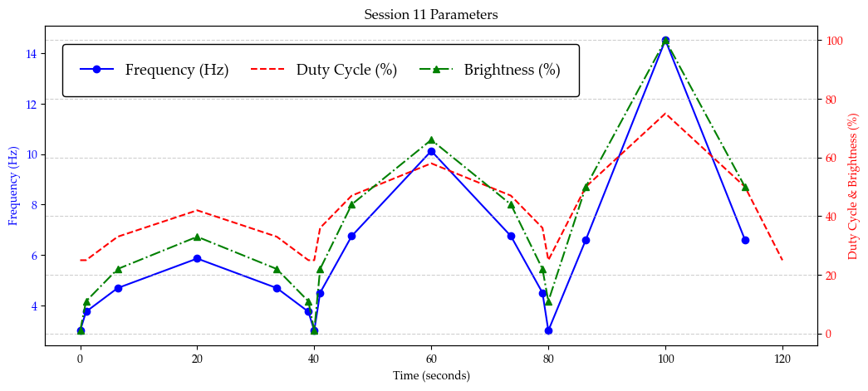
Figure S3.1. WP1 Session 11 dynamic sequence parameters. Session 11 combined the parameter classes tested separately in Sessions 1-10 into a single 120-second dynamic SLS sequence. The plot shows the time-varying frequency profile in Hz (blue, left y-axis), alongside duty cycle and brightness values expressed as percentages of the RX1 maximum-output setting used by the study team (red and green, right y-axis). The sequence was designed to move through low-, moderate-, and higher-intensity periods while remaining within the WP1 tolerability-tested parameter range. This dynamic session provided a short integrated test of whether combined frequency, duty-cycle, and luminance variation could produce a vivid but tolerable subjective visual experience before longer sequences were developed for WP2.
After each 2-minute session, participants were asked whether they had experienced any side effects. If they responded “no”, no further information was collected regarding session tolerability. If they reported side effects, they were presented with a list of symptoms from the Visual Discomfort Questionnaire and asked to indicate the frequency of each symptom (Vinkers et al., 2024).
Any reported side effect was then rated on a 10-point scale, referred to as the tolerability score. The scale ranged from 0, indicating no symptom discomfort, to 10, indicating the worst possible symptom discomfort. Scores of 3 were interpreted as mild discomfort, 4 as moderate discomfort, and scores above 7 as severe discomfort. If a participant rated any symptom above 7, testing of that specific parameter was immediately discontinued. If no symptoms were reported, the tolerability score was recorded as 0.

Discomfort by Session
Across all WP1 sessions, tolerability was high. Mean discomfort scores were low across the 11 parameter-testing sessions, with session-level means ranging from 0.16 to 0.84 out of 10. Averaging across session-level means, the overall mean discomfort score was approximately 0.49/10. All session-level upper one-sided 80% confidence limits remained far below the prespecified tolerability threshold of 7/10, with the highest upper confidence limit observed in Session 1 at 1.13. Thus, all WP1 parameter classes — luminance, frequency, frequency modulation, duty-cycle modulation, and the dynamic combined sequence — met the predefined tolerability criterion. For session-level tolerability scores, please see the attached Excel sheet, tab “WP1 Session Tolerability”.

Rationale for Parameter Range
WP1 was designed as a fixed-order parameter-probing study to identify stroboscopic settings that were sufficiently engaging to generate visual experience while remaining tolerable in individuals with depressive symptoms. The first 10 sessions each lasted 2 minutes and were divided into four 30-second sections. Each session manipulated one parameter family using a staircase-like progression: luminance, stimulation frequency, frequency shift, or duty cycle. The final session combined parameter families into a dynamic sequence.
The WP1 probing range supported the programme's intended active stroboscopic band: it covered theta-to-alpha and immediately adjacent low-beta flicker rates likely to produce visible flicker and visual phenomenology, while remaining anchored to the safety rationale in Schwartzman et al., (2025). Seizure-provoking responses to intermittent photic stimulation cluster most consistently around ~15-25 Hz, and recommend that routine SLS protocols should generally remain at or below 15 Hz, with only minimal dwell time above this threshold where higher frequencies are used. WP1 therefore tested the active range up to this conservative boundary, without entering the substantially faster wash-like regime used in the control sequences.

S4. WP1 Safety, VDQ, and Acute Symptom Monitoring

Full Side-Effect Frequency/Severity Table
Side-effect frequency was summarised at both the participant and session levels. For each WP1 session, participants first indicated whether any side effects had occurred. If they endorsed side effects, individual symptoms from the Visual Discomfort Questionnaire were recorded, and a 0–10 tolerability/discomfort score was collected. Sessions with no reported side effects were assigned a tolerability score of 0.

Open-Text Symptom Categories
The most commonly reported structured VDQ side-effect categories were headache and pressure behind the eyes, each reported a total of 18 times, followed by urge to blink frequently and participant-defined “other” symptoms, each reported in 16 instances. Among the participant-defined open-text responses, the only recurring symptom category was “eyelid jumping”, reported in 10 sessions. Open-text reports were reviewed descriptively and grouped into recurring symptom categories where possible. Most open-text reports were idiosyncratic or occurred rarely. No open-text category met criteria for a severe adverse reaction; these reports were therefore interpreted as transient visual or ocular discomfort phenomena within the broader VDQ side-effect profile.

WP1 Baseline and End-of-Sequence Mood Checks
Pre- and post-stimulation mood checks were summarised descriptively for PHQ-9, M3VAS mood/depression, M3VAS pleasure/anhedonia, and M3VAS suicidality. The expected denominator was defined as the WP1 analysed sample: 31 participants with at least three valid session-level discomfort rows in the WP1 Session Feedback file. Because the WP1 Testing End file contained M3VAS change-rating fields rather than directly observed raw post-stimulation VAS scores, M3VAS post-stimulation values were estimated from baseline values and end-session change ratings. Baseline M3VAS items were coded from 0 = bad to 100 = good, while M3VAS_CHANGE items were coded from −50 = worse to +50 = better; estimated post-stimulation M3VAS scores were therefore computed as baseline + change rating. Positive M3VAS post-minus-pre changes therefore indicate improvement. These summaries are descriptive and should be interpreted cautiously because sample sizes differed across measures and timepoints. For more details, please see the attached Excel sheet, tab “WP1 Pre/Post Mood Comparisons”.
For PHQ-9, baseline scores were available for 29/31 analysed participants. The mean baseline PHQ-9 score was 13.93 ± 3.00, with scores ranging from 7.00 to 19.00 and a 95% CI of [12.79, 15.07]. Among 25 participants with paired pre/post PHQ-9 data, mean PHQ-9 changed from 14.60 pre-stimulation to 13.32 post-stimulation, corresponding to a mean post-minus-pre change of −1.28 points (95% CI [−2.12, −0.44]; paired t = −3.151, p = 0.0043). Because lower PHQ-9 scores indicate fewer depressive symptoms, this pattern is consistent with a small descriptive reduction in depressive-symptom severity following WP1 stimulation exposure.
For M3VAS mood/depression, baseline scores were available for 28/31 analysed participants. The mean baseline score was 61.11 ± 15.53, with scores ranging from 19.00 to 87.00 and a 95% CI of [55.08, 67.13]. Among 22 participants with paired baseline and change-rating data, the mean estimated post-minus-pre change was +15.27 points (95% CI [8.84, 21.71]). Under the stated M3VAS coding, this positive change indicates improvement in mood/depression ratings following stimulation.
For M3VAS pleasure/anhedonia, baseline scores were available for 29/31 analysed participants. The mean baseline score was 51.38 ± 20.46, with scores ranging from 14.00 to 100.00 and a 95% CI of [43.60, 59.16]. Among 17 participants with paired baseline and change-rating data, the mean estimated post-minus-pre change was +5.00 points (95% CI [0.65, 9.35]). This indicates a smaller positive shift in pleasure/anhedonia ratings relative to the mood/depression item.
For M3VAS suicidality, baseline scores were available for 29/31 analysed participants. The mean baseline score was 32.00 ± 23.80, with scores ranging from 0.00 to 68.00 and a 95% CI of [22.95, 41.05]. Among 21 participants with paired baseline and change-rating data, the mean estimated post-minus-pre change was +11.67 points (95% CI [4.33, 19.00]). Under the stated M3VAS coding, this positive change indicates improvement in the suicidality-related VAS rating, although the interpretation should remain cautious given the estimated-post scoring and variability in available paired data.
Overall, the descriptive pattern across PHQ-9 and M3VAS measures suggests acute improvement following WP1 stimulation exposure, particularly for M3VAS mood/depression and suicidality-related ratings. However, these findings should not be interpreted as evidence of clinical efficacy. WP1 was designed primarily to evaluate parameter-level safety and tolerability, the M3VAS post-stimulation values were estimated from change ratings rather than directly observed post-stimulation VAS scores, and complete-case denominators differed across measures.

Discontinuations or Exclusions
No severe adverse reactions occurred as a direct result of WP1 stroboscopic stimulation. Severe adverse reactions were defined as events resulting in death, being life-threatening, or requiring hospitalisation. All predefined WP1 safety criteria were met.

One-Sided Upper 80% Confidence Limits
The primary tolerability criterion was evaluated using one-sided upper 80% confidence limits around session-level mean discomfort scores. For each session, the upper confidence limit was calculated as mean + z × SE, where z = 0.8416 for an upper 80% one-sided normal approximation. A session met the tolerability criterion if the upper 80% confidence limit remained below 7 out of 10.
In WP1, all 11 sessions met this predefined tolerability criterion. Across sessions, mean discomfort scores ranged from 0.16 to 0.84 out of 10, and the corresponding upper one-sided 80% confidence limits ranged from 0.25 to 1.13. The highest upper confidence limit was observed in Session 1 and remained far below the prespecified threshold. No session produced discontinuations based on discomfort scores exceeding the threshold.

S5. Intervention and Low-Phenomenology Control Construction
WP2 SLS Parameters and Sequence Construction
Specifics surrounding the SLS parameters and sequence justification logic can be found in the accompanying Excel sheet, tabs “Parameter Bins”, “Sonata Form Structure”, “Sequence Construction”, and “WP2 Parameters”.

Intervention Construction
The intervention was constructed from a set of dynamic stroboscopic sequences whose overall organisation was modelled on the structure of classical sonata form. Five source works were used as structural templates: Mozart K.545 in C major, Schubert D.960 in B-flat major, Beethoven Op.13 Pathétique, Beethoven Op.53 Waldstein, and Beethoven Op.27 No.2 Moonlight. Each source sequence was translated into a dynamic stroboscopic time series designed to include a gradual opening, a more intense middle/developmental portion, and a resolving final portion.
Across the construction scripts, the roXiva/RX1 sequence format was implemented using four oscillator channels. Helper functions generated LED assignments, formatted oscillator-specific STP lines, and exported full stimulation scripts with explicit duration, frequency, duty-cycle, luminance, and LED-assignment fields. In the dual-group sequence format, OSC1–OSC2 used one parameter pair and OSC3–OSC4 used a second parameter pair, allowing active stroboscopic and wash-light components to be specified separately.
Active intervention flicker was constrained to the 3–15 Hz band, with duty cycle and luminance varying dynamically across the sequence. Wash phases were specified using 60 Hz stimulation, and dark phases were specified by setting luminance values to 0.
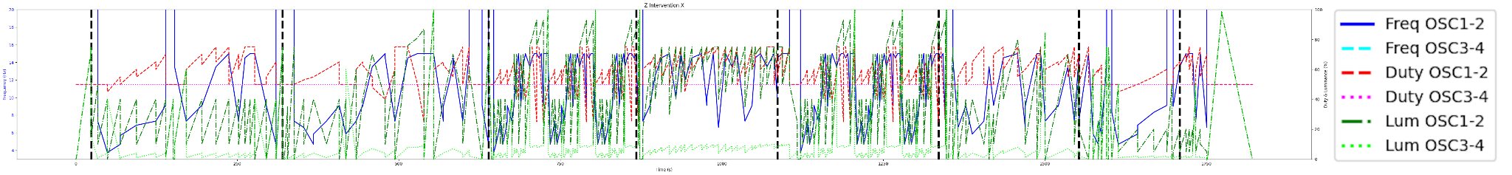
Figure S5.1. Intervention stimulus sequence used in WP2. The plot shows the programmed time-varying stimulation profile across the session. The blue line denotes flicker frequency (Hz; left y-axis), the red line denotes duty cycle (%; right y-axis), and the green line denotes brightness/luminance (%; right y-axis). Vertical guide lines mark programmed sequence boundaries or transition points. The intervention sequence was designed to maintain perceptually engaging closed-eye stroboscopic stimulation within the active parameter range selected from WP1, while varying frequency, duty cycle and luminance to support sustained visual phenomenology and tolerability.

Low-Phenomenology Control Construction
The low-phenomenology control condition was designed to preserve overall session structure, luminance context, timing, and device interaction while reducing the vivid stroboscopic phenomenology expected from the intervention. Rather than using an inert no-light or constant-light control, the control retained visible light stimulation and matched the broad temporal architecture of the active sequence. The key manipulation was the relative balance between active flicker and wash-light components: the intervention emphasised active stroboscopic flicker against a lower wash component, whereas the control increased the relative wash-light contribution and reduced the phenomenology-generating flicker contribution. This design was intended to improve comparator credibility and support operational masking while producing a lower-phenomenology comparison condition.
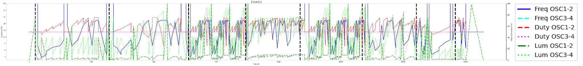
Figure S5.2. Low-phenomenology control stimulus sequence used in WP2. The plot shows the programmed time-varying stimulation profile across the session. The blue line denotes flicker frequency (Hz; left y-axis), the red line denotes duty cycle (%; right y-axis), and the green line denotes brightness/luminance (%; right y-axis). Vertical guide lines mark programmed sequence boundaries or transition points. The control sequence was designed to preserve the overall session structure and programmed parameter timing while using low-intensity settings intended to minimise visual phenomenology and maintain tolerability.

Interim Condensed Sequences and DTW Fidelity
The full WP2 intervention and control sequences were approximately 30 minutes long, so the interim study required shorter versions that could be administered in a within-participant calibration design. Condensed versions were therefore generated to preserve the proportional representation, temporal density, and parameter structure of the longer intervention and control sequences. Candidate subsections were selected to minimise deviations from the full-sequence frequency and luminance centroids while preserving segmental variability and avoiding abrupt transitions at segment boundaries.
Fidelity between the original and condensed sequences was evaluated using Dynamic Time Warping (DTW), a trajectory-alignment method for comparing time series of different lengths. DTW was used to align the full and condensed parameter trajectories and quantify the accumulated deviation between them. Segment-level DTW values were normalised by the length of the corresponding original segment, and total deviation was summarised using a length-weighted average across segments. Wash-ramp and dark phases were excluded from these comparisons so that the DTW analysis focused on the active phenomenology-relevant portions of the sequence.

Sonata Form Structure and Condensation Logic
The full sonata-form sequence structure, sequence-condensation logic, interim calibration checks, parameter bins, overall fidelity summary, and segment-level fidelity outputs are provided in the accompanying Excel workbook. Across all active segments, the condensed sequence showed a mean absolute frequency difference of 1.12 Hz (12.43%), a duty-cycle difference of 1.68 percentage points (2.89%), and a luminance difference of 4.23 percentage points (14.02%). Length-adjusted per-step Dynamic Time Warping (DTW) deviations were 0.320 Hz for frequency, 0.078 percentage points for duty cycle, and 0.470 percentage points for luminance.
Segment-level analyses indicated that the central peak segment was especially well preserved for frequency, with a full-sequence mean of 10.17 Hz and a condensed-sequence mean of 10.16 Hz. The largest relative segment-level deviation was observed for luminance in Segment B, with a relative difference of 22.04%. The smallest relative segment-level deviation was observed for frequency in the Peak segment, with a relative difference of 0.17%. Overall, these results indicate that the condensed interim-study sequence retained the central temporal and parametric features of the full-length candidate sequence while reducing the duration to a feasible calibration format.

S6. Interim Bridge Study

Recruitment and Eligibility
The Interim Study was conducted as a bridge study to test whether the low-phenomenology control sequence reduced subjective visual experience relative to the intervention sequence while preserving a credible stimulation context. The prescreening survey was opened 132 times between April 6, 2025 and April 17, 2025. For consistency with Figure 1 and the demographic workbook, the broad screened denominator was defined as 109 unique prescreening records. Within the operational recruitment funnel, 98 individuals completed an evaluable prescreening survey, 61 completed/evaluable prescreens passed screening, 40 booked a testing slot, and 33 attended testing. Exclusions included safety-screen failures, demographic or clinical exclusions, medication/supplement unfamiliarity, substance-use history, diagnostic confounds, and elevated trait anxiety (State-Trait Anxiety Inventory; STAI-Trait >60).

Final Tested and Analysed Denominators
The final attended interim sample was n = 33. The analysed denominator for questionnaire-based analyses was n = 32, defined as the number of participants with valid condition-level Six-Dimensional Visual Hallucination Questionnaire (6D-VHQ) and four-item immediate experience-rating data after removal of incomplete or invalid rows.

STAI Threshold
Trait anxiety was assessed during screening to reduce risk of distress or adverse experience in the normative bridge sample. The Interim Study excluded participants with trait anxiety scores above the implemented threshold of 60, comprising five individuals.

6D-VHQ and 4EXP Analyses
The Six-Dimensional Visual Hallucination Questionnaire (6D-VHQ) was scored across six dimensions: Geometric Content, Semantic Content, Detail, Vividness, Entropy, and Focality. Items 10, 11, 12, and 17 were reverse-scored using a 1-5 scale transformation before dimension scores were computed. Dimension scores were calculated as the mean of the three corresponding items for each participant and session. Condition was assigned using the study condition/sequence mapping for each session rather than raw session order.
The primary interim analysis modelled 6D-VHQ scores as a function of condition using repeated-measures models with participant-level random intercepts. Intervention-minus-control paired mean differences were positive for Geometric Content (mean difference = 1.14, 95% CI [0.73, 1.54], p < .001), Detail (1.05, 95% CI [0.60, 1.50], p < .001), Vividness (0.97, 95% CI [0.54, 1.39], p < .001), Focality (0.42, 95% CI [0.11, 0.73], p = .009), and Semantic Content (0.41, 95% CI [0.08, 0.75], p = .018). Entropy showed no clear condition difference (-0.04, 95% CI [-0.36, 0.29], p = .822).
Four-item immediate experience ratings (EXP4: pleasure, engagement, arousal, and discomfort) were analysed as exploratory subjective-response outcomes. The exploratory model was EXP4 score ~ Condition + (1 | Participant), with nondirectional p < 0.05 tests.

Ranking Denominator
Visual-experience rankings were collected at the end of each testing block, after participants had completed one intervention and one control session. The ranking item asked which session in that block produced the greater visual experience. Because each participant completed two blocks, the maximum ranking denominator was two rankings per participant. Rankings were therefore analysed at the block level rather than the individual session-response level. In the analysed ranking dataset, intervention sessions were selected as producing the stronger visual experience in 46/64 binary rankings, compared with 18/64 rankings for the control. Because each participant contributed two rankings, this result is interpreted as a descriptive ranking-level check rather than a participant-level inferential test. Some participants may have interpreted the item as asking which session they preferred overall rather than which produced greater visual intensity; this is therefore treated as a limitation of the ranking measure.

Missing/Invalid Rankings
Ranking responses were considered valid only where both sessions in the corresponding block had been completed and the participant selected one of the two within-block sessions as producing the greater visual experience. Empty ranking fields outside the end-of-block row were not treated as missing, because the ranking question was administered only once per block. Invalid rankings were defined as responses outside the allowable within-block session codes, duplicate or ambiguous entries, or rankings from blocks with incomplete session data. The analysed ranking denominator therefore comprised valid block-level comparisons rather than all session-level rows.

Block/Order Checks
The interim design included two blocks of two randomised trials, with one intervention and one control sequence in each block. Initial checks examined whether intervention sessions differed across blocks and whether control sessions differed across blocks. Where within-condition block differences were present, the planned model was 6D-VHQ score ~ Condition * Block + (1 | Participant), allowing exploratory assessment of block/order effects and possible audiovisual-alignment effects. Descriptive checks suggested higher ratings for the aligned intervention sequence than the shuffled intervention sequence on Geometric Content, Detail, Vividness, and Semantic Content. These block/order analyses were treated as exploratory calibration checks rather than confirmatory tests of stimulus mechanism.

Participant Qualitative Reports
After each session, participants were asked open verbal questions about the subjective experience, including “What did you see?” and “What was it like?”. Responses were used descriptively to contextualise questionnaire ratings and to examine whether intervention sessions elicited richer or more vivid visual content than control sessions. Qualitative reports were not treated as confirmatory endpoints. They are summarised using coded descriptive categories, with word clouds presented only as illustrative visual summaries of recurring terms.
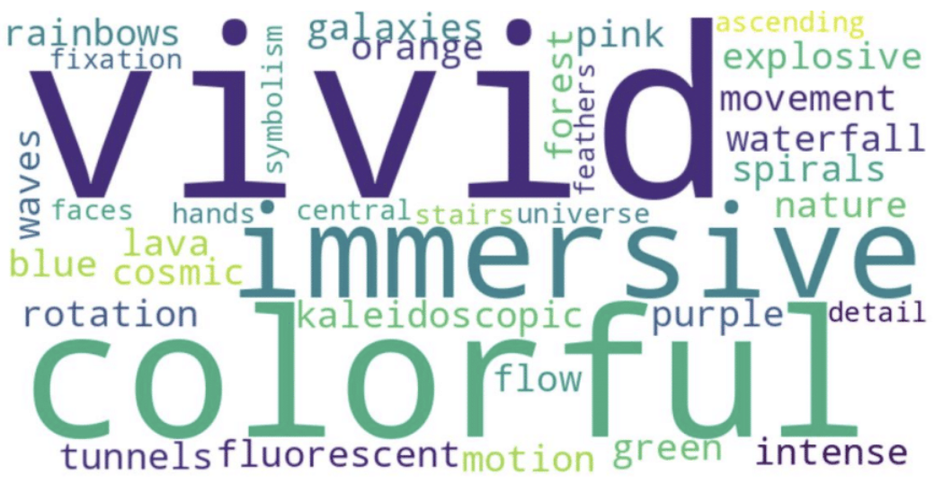
Figure S6a. Illustrative word cloud of verbal reports from intervention sessions. Word cloud summarising recurring terms from participants’ open verbal descriptions after intervention SLS sessions in the interim bridge study. Larger words indicate more frequent terms after text preprocessing. The figure is intended as an illustrative summary of recurring experiential content only; qualitative interpretation should be based on the accompanying coded descriptive summary rather than on word-frequency visualisation alone.
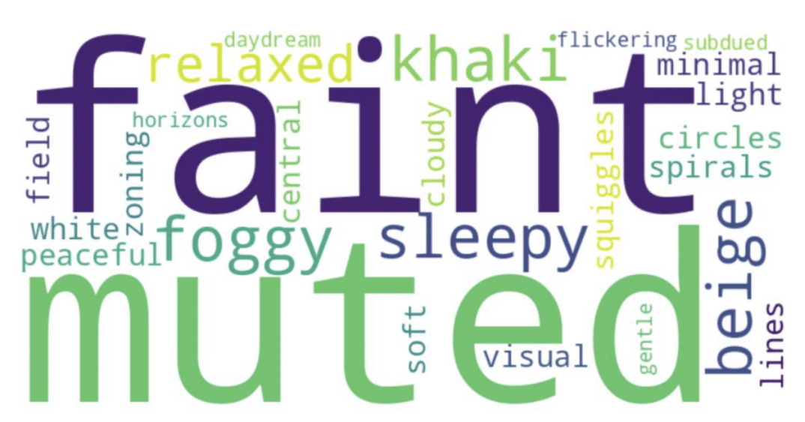
S6b. Illustrative word cloud of verbal reports from the Control sessions. Word cloud summarising recurring terms from participants’ open verbal descriptions after low-phenomenology control SLS sessions in the interim bridge study. Larger words indicate more frequent terms after text preprocessing. The figure is intended as an illustrative summary of recurring experiential content only; qualitative interpretation should be based on the accompanying coded descriptive summary rather than on word-frequency visualisation alone.

Interim SLS and Audiovisual Parameter 2 × 2 Sequence-Calibration Design
The interim protocol used a 2 × 2 sequence-calibration design crossing condition (intervention vs low-phenomenology control) with sequence order/audiovisual alignment (standard vs shuffled). The first paired series retained the standard representative block order, progressing from A to B to C1 to Peak to D to E after the onset and warmup periods. The second paired series used the corresponding shuffled order, progressing from B to A to Peak to C1 to E to D before cooldown. Both series preserved the same local oscillator parameter families, including the frequency, duty-cycle, and luminance profiles within each representative block, but differed in the temporal ordering of those blocks.
Within each paired series, the intervention and control sequences shared the same temporal scaffold. The intervention sequence placed the higher-luminance, dynamically varying stroboscopic component on the active oscillator group, while the complementary oscillator group served primarily as a lower-luminance wash-light channel. The control sequence retained the same broad timing and oscillator progression but shifted luminance emphasis away from the active stroboscopic component and toward the wash-light component. This reduced the expected phenomenological salience of flicker while preserving the general timing, transition structure, and audiovisual context.
The shuffled second series was included to avoid repeating an identical audiovisual trajectory and to test the intervention-control contrast under a second order/alignment variant. By rearranging the representative visual blocks while preserving their local parameter profiles, the second intervention/control pair altered how the isochronic auditory pulse motifs aligned with the visual oscillator trajectory over time. Thus, the second series should be understood as an audiovisual-alignment/order variant rather than as a distinct stimulus family.
In the accompanying parameter workbook, each oscillator cell reports frequency, duty cycle, and luminance as start-to-end values for that time step. OSC1-2 and OSC3-4 refer to the two oscillator groups encoded in the source STP-generation script. In this coding framework, 60 Hz entries denote the high-rate wash-like component rather than the lower-frequency stroboscopic range used to drive stronger visual phenomenology. Full time-step parameter details for the four interim sequences are provided in the accompanying Excel workbook, tab “Interim Parameters”.

Interim SLS Parameters for Unshuffled Audiovisual Conditions
Unshuffled Intervention
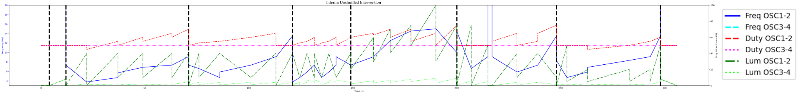
Figure S6c. Interim unshuffled intervention SLS parameter trajectory. Parameter trajectory for the unshuffled intervention sequence used in the interim bridge study. The sequence follows the standard representative block order, progressing from A to B to C1 to Peak to D to E after onset and warmup. Lines show the programmed frequency, duty-cycle, and luminance profiles for OSC1–2 and OSC3–4 across time. Vertical dashed lines mark transitions between representative sequence blocks. The intervention condition places the more salient dynamically varying stroboscopic component on the active oscillator group, with the complementary oscillator group serving primarily as a lower-luminance wash-light channel. In this coding framework, 60 Hz entries denote the high-rate wash-like component rather than the lower-frequency stroboscopic range intended to drive stronger visual phenomenology.

Unshuffled Control
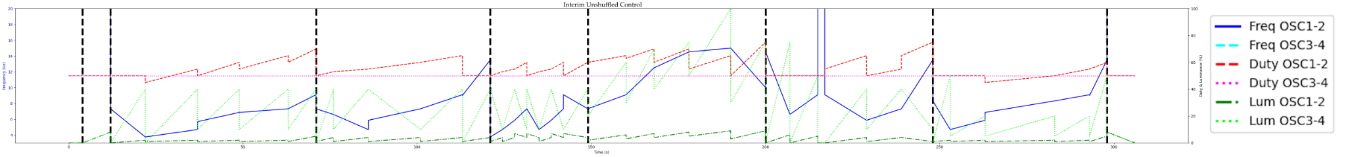
Figure S6d. Interim unshuffled low-phenomenology control SLS parameter trajectory. Parameter trajectory for the unshuffled low-phenomenology control sequence. This sequence preserves the same standard temporal scaffold and representative block order as the unshuffled intervention sequence, but shifts luminance emphasis away from the active stroboscopic component and toward the wash-light component. This control construction was designed to reduce expected phenomenological salience while retaining comparable timing, transition structure, oscillator progression, and audiovisual context. Lines show frequency, duty cycle, and luminance values for OSC1–2 and OSC3–4, with vertical dashed lines indicating transitions between representative blocks.

Interim SLS Parameters for Shuffled Audiovisual Conditions
Shuffled Intervention
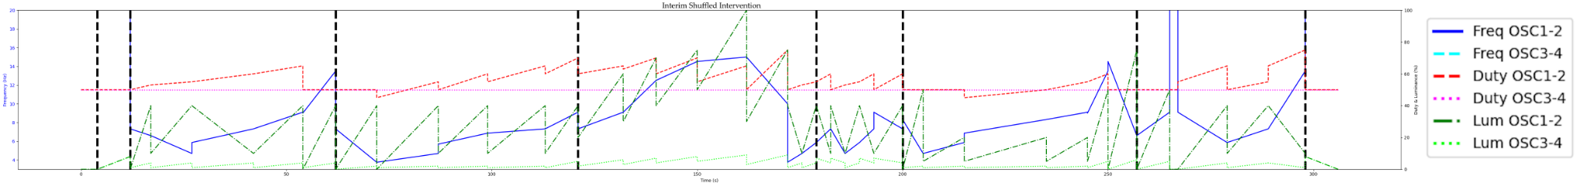
Figure S6e. Interim shuffled intervention SLS parameter trajectory. Parameter trajectory for the shuffled intervention sequence used as the second audiovisual order/alignment variant in the interim bridge study. The shuffled sequence rearranges the representative visual blocks while preserving their local oscillator parameter profiles, progressing from B to A to Peak to C1 to E to D before cooldown. This manipulation altered how isochronic auditory pulse motifs aligned with the visual oscillator trajectory over time without introducing a distinct stimulus family. Lines show programmed frequency, duty-cycle, and luminance profiles for OSC1–2 and OSC3–4; vertical dashed lines mark block transitions.

Shuffled Control
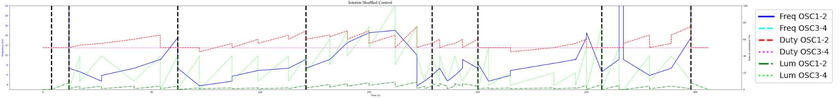
Figure S6f. Interim shuffled low-phenomenology control SLS parameter trajectory. Parameter trajectory for the shuffled low-phenomenology control sequence. This sequence shares the same shuffled temporal order and audiovisual alignment variant as the shuffled intervention sequence, but applies the low-phenomenology control luminance arrangement, reducing emphasis on the active stroboscopic component while preserving broad timing, transition structure, and oscillator progression. Lines show frequency, duty cycle, and luminance values for OSC1–2 and OSC3–4 across time, and vertical dashed lines indicate representative block transitions. Full time-step parameters for all four interim sequences are provided in the accompanying Excel workbook, tab “Interim Parameters.”

S7. WP2 Full Procedure and Assessment Schedule

Visit-by-Visit Schedule
WP2 implemented a four-session supervised stimulation protocol, with one supervised SLS session per week over four weeks. Participants completed pre-session questionnaires before stimulation and post-session questionnaires after stimulation.
The attached Excel workbook tabs “WP2 Assessment Schedule” and “WP2 Data Collection Details” summarise the WP2 assessment and data-collection schedule.
Eligibility and safety screening were completed at pre-screening, followed by baseline clinical, expectancy, and randomisation/allocation-related measures at the first pre-session assessment. Clinical symptom measures were collected longitudinally across the protocol, with PHQ-9, M3VAS, SPANE, and short-term change ratings repeated during the supervised-session period and SMS follow-up window. Broader clinical scales, including BDI-II, BAI, and MADRS-S, were collected at baseline and endpoint.
Acute experiential measures, including altered-state phenomenology, visual phenomenology, engagement, pleasure, discomfort, drowsiness, and tolerability ratings, were collected after each supervised stimulation session. Safety, adverse-event, attendance, questionnaire-completion, missingness, and protocol-adherence information were tracked throughout the intervention period and final follow-up.

Pre-/Post- Measures
Pre-session measures included depressive and anxiety symptom measures, baseline expectancy/credibility measures, and wellbeing monitoring variables. Post-session measures included tolerability, side effects, acute experiential ratings, and symptom/wellbeing measures as specified by visit. The final analysis dataset identifies PHQ-9 and BDI-II as core clinical outcome fields and includes BAI, MADRS-S, M3VAS, M3VAS-Change, SPANE, expectancy items, 6D-VHQ, and 11-ASC variables where present. The attached Excel tab “WP2 Scale Definitions” further expands on these applied measures.

SMS Timing after Sessions 1-3
Between supervised sessions, participants completed brief SMS-based follow-up measures 1, 3, and 5 days after stimulation. The tracking notebooks parsed both WP2 session calendars and SMS calendars, extracting participant IDs, session numbers, and SMS numbers from calendar metadata.

One-Week Follow-Up
After the fourth supervised session, participants completed a final follow-up assessment approximately one week later. This assessment captured short-term symptom and affective status after completion of the four-session protocol.

Randomisation and Allocation Concealment
WP2 used 1:1 allocation to SLS intervention or low-phenomenology control. Allocation was stratified by psychoactive medication status and baseline PHQ-9 severity, defined as PHQ-9 scores of 5-16 versus 17-27. Within each stratum, a pre-generated allocation sequence used randomly permuted blocks of four, with two intervention and two control assignments per block. Condition codes and template filenames were concealed from participants and testing researchers. Perceived allocation, credibility and masking success were not assessed in this feasibility study.

Blinding Workflow
WP2 used masked sequence names rather than condition-identifying labels for researcher-facing session administration. Randomisation was implemented in a Python/Colab stratification notebook using four strata defined by baseline PHQ-9 severity and current medication status: low PHQ-9 with medication, low PHQ-9 without medication, high PHQ-9 with medication, and high PHQ-9 without medication. PHQ-9 severity was categorised as low for scores of 5–16 and high for scores of 17–27. The medication stratum was intentionally broad and was not restricted to antidepressants or mood-related treatment; it reflected any current medication exposure recorded at screening, alongside safety exclusions for current antipsychotic use and for supplements, herbs, or medications taken for too short a period to establish familiarity. Within each stratum, participants were allocated using permuted blocks of size four, with two Intervention and two Control assignments per block.
The notebook generated an assignment CSV containing the participant ID, stratum, condition, and a blinded sequence name. Researcher-facing session administration used only the blinded sequence names, rather than labels such as “Intervention” or “Control”. The blinded sequence names were generated as reproducible hashed codes using a fixed seed, so that files could be named consistently without revealing allocation. Specifically, five Intervention and five Control sequence-code names were generated from SHA-256 hashes and used to create blinded template filenames of the form WP2-XXXXXX.
Balance checks exposing condition-level counts were treated as potentially unblinding. The stratification notebook therefore included a guard whereby condition balance checks were skipped when fewer than four new participants had been added, because checking an incomplete block could reveal allocation. When a full block or more had been added, the script required explicit confirmation before displaying condition-by-stratum counts. These outputs were restricted to the PI or non-blinded workflow members and were not intended for routine researcher-facing session delivery.

Allocation Concealment
Allocation concealment was implemented by separating condition assignment from researcher-facing sequence delivery. Eligible participants were assigned to a masked sequence code, and the mapping between sequence code and condition was retained in the assignment file. Researcher-facing materials and session files used the masked sequence codes rather than condition-identifying labels.
The workflow also preserved prior assignments when the stratification script was rerun. On each run, the notebook loaded the existing assignment CSV, removed participants who had become ineligible before randomisation or who never attended Session 1, and then identified only newly eligible, unassigned participants. Existing participants retained their original condition and sequence name. New participants were assigned according to their stratum-specific block position, with the block order reproducibly generated from the fixed seed, stratum label, and block number. This ensured that rerunning the notebook did not reshuffle or overwrite previous allocations.
The template files used for session delivery were duplicated under masked sequence-code filenames. Separate source templates existed for the low-phenomenology control and intervention sequences, but the researcher-facing files were renamed using the masked WP2-XXXXXX sequence codes. Thus, session administrators could load the appropriate sequence file without seeing condition-identifying information.

Stratification Script Logic
The WP2 stratification workflow used the prescreening file to identify participants eligible for allocation. Participants were retained for randomisation only if they had passed prescreening, had either booked a session or indicated that no slot was available, had a valid PHQ-9 severity category, and had valid pharmacological-treatment status information. Participants who never attended Session 1, withdrew before arrival, were later identified as ineligible, or dropped out at the taster stage were excluded from the active randomisation file before new allocations were generated.
The script defined four strata by crossing PHQ-9 severity with current pharmacological-treatment status: lower PHQ-9 with medication, lower PHQ-9 without medication, higher PHQ-9 with medication, and higher PHQ-9 without medication. PHQ-9 severity was categorised as lower for scores of 5-16 and higher for scores of 17-27.
Within each stratum, new participants were assigned using permuted blocks of size four, with two intervention and two control allocations per block. A fixed seed was used to make the block ordering reproducible. For each stratum and block number, the script generated a deterministic randomisation order by hashing the seed, stratum, and block index, then shuffling a block containing two intervention and two control labels. This produced reproducible allocation while maintaining balance within strata over complete blocks.
The notebook also generated masked sequence names using SHA-256 hashes based on the fixed seed, condition, and sequence index. Five masked sequence codes were generated for intervention and five for control. These codes were then used to duplicate the underlying sequence template files, so that researcher-facing filenames did not reveal condition assignment.
A separate balance-checking section of the notebook was used for monitoring overall allocation by condition and stratum. Because these outputs reveal condition counts, they were treated as unmasked monitoring outputs and were restricted to PI or non-masked workflow use.

Debriefing
After completing their final follow-up procedures, participants were debriefed by email regarding the study aims, the use of both intervention and low-phenomenology control sequences, their allocated condition, and the exploratory nature of the symptom outcomes. The debriefing text explained that both groups completed the same questionnaire and session schedule, but that the control condition used strobe sequences designed to minimise stroboscopic phenomenology while preserving the broader session context.
Participants were reminded that the study was not diagnostic and was not designed to provide clinical treatment. Where appropriate, participants were signposted again to local and national mental-health support resources, including University of Sussex support routes for students. The debriefing workflow used the assignment file to retrieve each participant’s allocation and insert the appropriate condition label into the debriefing email.

S8. WP2 Feasibility, Adherence, and Missingness

Scheduled-Event Denominator
The scheduled-event denominator distinguished between participants who passed screening, participants who were randomised, participants who attended Session 1, and participants expected to provide post-session data at each subsequent visit. The WP2 monitoring notebook explicitly separated never-attended IDs, post-Session-1 dropouts, and taster-session dropouts. This distinction is important because participants who never attended Session 1 should not be counted as missing post-baseline treatment data, whereas participants who attended Session 1 but subsequently withdrew contribute to retention and adherence denominators.
The WP2 denominator audit distinguished between participants who passed screening (n = 160), participants who were randomised (n = 84),participants who completed the Session 1 stimulation session (n = 81), participants with post-Session-1 data (n = 79), and participants with Session 4/endpoint data (n = 70).
Using the broad treatment-started definition, Session 1 attendance was defined by evidence of either a pre-session-1 or post-session-1 form. A stricter post-treatment evidence definition counted participants with post-Session-1 data only (n = 79). Participants who never attended Session 1 should not be counted as missing post-baseline treatment data, whereas participants who started Session 1 but did not continue contribute to retention and adherence denominators.
The audit identified n = 7 post-Session-1 dropouts using data-defined or manual criteria, and n = 1 possible taster-session dropouts based on detected text fields or manual override.
By Session 4, n = 70 participants had evidence of attending or starting the session, and n = 70 provided post-Session-4 data.
Session-specific scheduled-event denominators:
Session 1: scheduled-event denominator = 84; post-session data available = 79; missing among scheduled = 5; completion = 79/84 (94.05%).
Session 2: scheduled-event denominator = 74; post-session data available = 74; missing among scheduled = 0; completion = 74/74 (100.0%).
Session 3: scheduled-event denominator = 71; post-session data available = 71; missing among scheduled = 0; completion = 71/71 (100.0%).
Session 4: scheduled-event denominator = 70; post-session data available = 70; missing among scheduled = 0; completion = 70/70 (100.0%).

Attendance by Arm/Session
Attendance was summarised as the number and percentage of randomised participants who completed each scheduled stimulation session, separately by arm. Of 84 randomised participants, 42 were allocated to intervention and 42 to low-phenomenology control. Session completion was 39/42, 35/42, 32/42, and 31/42 in the control arm across Sessions 1-4, and 42/42, 39/42, 39/42, and 39/42 in the intervention arm. These values are reported as arm-specific feasibility/adherence outcomes and should be interpreted alongside the study-flow figure, which reports screening, randomisation, follow-up, and analysis denominators. Per-arm/session attendance is summarised in the attached Excel sheet, tab “WP2 Attendance by Arm/Session”.

Questionnaire Completion
Data-collection adherence was calculated as observed/expected responses at each scheduled data-collection event. Pre-session and post-session forms were expected for participants with evidence of attending the corresponding session. The three SMS follow-ups after Sessions 1, 2, and 3 were treated as separate expected events using session_n and sms_n. Final SMS/post-treatment follow-up was expected for participants with evidence of attending Session 4.
Across all expected event-person observations, total data-collection adherence was 1174/1340 (87.6%). For all details, please see the attached Excel workbook, tab “WP2 Data-Collection Adherence”.
Lowest-completion events:
SMS 2 after Session 3: 43/71 (60.6%), missing n = 28
SMS 2 after Session 2: 50/74 (67.6%), missing n = 24
SMS 1 after Session 2: 57/74 (77.0%), missing n = 17
SMS 1 after Session 3: 55/71 (77.5%), missing n = 16
SMS 3 after Session 3: 55/71 (77.5%), missing n = 16

Reasons for Missed Sessions / Withdrawal
Dropout reasons were summarised using the WP2 dropout questionnaire and manually curated attendance categories. The WP2 monitoring notebook mapped free-text dropout reasons into broader categories including tolerability, scheduling, other, and unknown. Where possible, missed sessions and withdrawals were tabulated by arm and category, separating participants who never attended Session 1 from participants who attended at least one supervised session and then missed later sessions or endpoint assessment.
Of the 14 WP2 discontinuations, 3 occurred in the intervention arm and 11 in the control arm. Four participants discontinued due to discomfort, split evenly across arms (2 intervention, 2 control). Two participants discontinued due to perceived negative effects (e.g., mild headache), both in the control arm. The remaining eight discontinuations were attributed to scheduling/logistical constraints, comprising one intervention participant and seven control participants.

Differential Endpoint Attrition and Baseline Characteristics of Completers/Non-Completers
Endpoint availability differed between randomised arms. Post-Session-4 data were available for 39/42 Intervention participants (92.9%) and 31/42 Control participants (73.8%), corresponding to an endpoint unavailability of 3/42 (7.1%) and 11/42 (26.2%), respectively; however, the randomised denominator included three Control participants who did not complete Session 1. Among participants who initiated Session 1, retention to the endpoint was 39/42 (92.9%) in Intervention and 31/39 (79.5%) in Control. This distinction does not remove the differential-loss concern, but separates post-randomisation non-completion from loss after fuller treatment initiation.
To examine whether endpoint availability selected participants with systematically different baseline characteristics, baseline BDI-II, PHQ-9 and treatment expectancy were summarised descriptively for endpoint completers and non-completers within each arm. In Intervention, completers and non-completers were similar in baseline BDI-II (26.7 vs 26.0) and PHQ-9 (12.5 vs 12.3), while mean expectancy was somewhat higher among completers (91.9 vs 86.3). In Control, completers had higher baseline BDI-II scores than non-completers with complete baseline data (29.1 vs 24.1), whereas baseline PHQ-9 was slightly lower (13.1 vs 14.5) and expectancy was higher (89.1 vs 83.6).
Early tolerability was also considered as a possible contributor to retention. Mean Session-1 discomfort was numerically higher in Control than Intervention (0.72 vs 0.22 on the 0-10 scale), although both values were low in absolute terms. This does not establish discomfort as a cause of withdrawal, but early discomfort is therefore retained alongside scheduling burden, symptom fluctuation, expectancy and experiential engagement as a plausible contributor to differential completion.
Withdrawal reasons were also unevenly distributed between arms. Both discontinuations attributed to perceived negative effects occurred in Control, as did seven of eight discontinuations attributed to scheduling or logistical constraints. Four discontinuations were attributed to discomfort, split evenly between arms. These descriptive patterns do not identify the missing-data mechanism, but further support treating the available-case clinical contrasts cautiously.
These comparisons do not indicate a single consistent severity-related selection mechanism. Accordingly, differential endpoint availability cannot itself establish the direction or magnitude of bias, but it makes the missing-data mechanism uncertain and limits the weight that can be placed on available-case clinical contrasts.

Available-Case Rules
Analyses used available-case rules appropriate to each outcome. Safety and tolerability summaries included all completed post-session tolerability reports. Repeated-session plots used all available session-level data without imputing missing visits. Endpoint clinical analyses used participants with valid baseline and endpoint data for the relevant measure. Questionnaire scale scores were computed where sufficient item-level data were available according to the scale-specific scoring rules; otherwise, the relevant participant-timepoint was treated as missing for that outcome.

Deviations from Protocol
Protocol deviations should be reported descriptively and separated from missing data. Examples include manual scheduling issues, participants who booked but never attended, participants who withdrew before stimulation, participants who discontinued during or after a taster session, and cases where session timing or SMS timing deviated from the intended schedule. Deviations were not automatically treated as exclusions unless they invalidated the relevant analysis denominator. Overall scheduled-event adherence was 87.6% (1,174/1,340 scheduled events), and endpoint availability was 70/84 (83.3%).

Retention Against Registered Criteria
Retention was evaluated against the programme’s pre-specified feasibility criteria. The primary feasibility interpretation focused on whether recruitment, retention, and endpoint availability were sufficient to support progression to a future definitive trial, rather than on formal efficacy testing.
The main registered-feasibility denominator was the randomised WP2 sample. Endpoint data were available for 70/84 participants, giving overall endpoint availability of 83.3% (Wilson 95% CI: 73.9-89.8%), which met the registered retention benchmark of at least 80%. Arm-specific endpoint availability was 31/42 in the control arm (73.8%, 95% CI: 58.9-84.7%) and 39/42 in the intervention arm (92.9%, 95% CI: 81.0-97.5%). These arm-specific values are reported descriptively and were not treated as formal comparative tests.
Where retention is instead calculated among participants who completed Session 1, the corresponding denominator is 70/81, or 86.4% (95% CI: 77.3-92.2%). This Session-1-starter denominator is useful for adherence interpretation but should be kept separate from the registered 70/84 endpoint-availability criterion.

S9. WP2 Safety and Tolerability

Adverse Reactions, Serious Adverse Events, and Safeguarding-Triggered Discontinuations
No serious adverse events or safeguarding-triggered discontinuations were recorded during WP2. Serious adverse events were therefore 0/84 among randomised participants and 0/81 among participants who completed at least one supervised stimulation session. Adverse reactions were summarised from post-session tolerability and side-effect reports. Serious adverse events were defined as events resulting in death, life-threatening risk, hospitalisation, or comparable serious clinical deterioration. Session- and arm-specific FIBSER/side-effect ratings can be found in the accompanying Excel workbook, tab “WP2 FIBSER SE Summaries by Arm/Session”.

FIBSER Summaries
FIBSER-style side-effect summaries indicated that raw side-effect field endorsement substantially overestimated clinically interpretable negative effects. Before text/severity cleaning, any side-effect field was endorsed by 14/42 participants in both arms after Session 1 (33.3%), with lower raw endorsement rates thereafter. After cleaning, combined post-session and follow-up negative side-effect endorsement was highest after Session 1 in both arms: 9/42 (21.4%) in the Intervention arm and 11/42 (26.2%) in the Control arm. Cleaned combined negative endorsement then declined across subsequent sessions, reaching 0/42 (0.0%) by Session 4 in the Intervention arm and 1/42 (2.4%) in the Control arm. Cleaning removed unsupported or non-negative endorsements, including 5/42 (11.9%) Intervention and 3/42 (7.1%) Control records after Session 1, with fewer removals thereafter. Mean post-session VDQ discomfort scores remained low throughout, with the highest mean observed after Control Session 1 (0.95 ± 2.41) and all other session means below 0.33. Overall, the cleaned FIBSER/side-effect summaries support the interpretation that reported adverse effects were generally infrequent, mild, and transient, and that raw endorsement fields were conservatively screened to avoid counting non-negative or unsupported responses as adverse effects.

Discomfort Ratings by Session/Arm
WP2 tolerability was monitored using post-session discomfort/tolerability ratings on a 0-10 scale. The WP2 monitoring notebook computed condition-by-timepoint means, standard deviations, standard errors, and one-sided upper 80% confidence limits using z = 0.8416. The tolerability criterion was evaluated by confirming that all upper 80% confidence limits remained below the predefined severe-discomfort threshold of 7/10.
Mean discomfort ratings were low across all sessions and both arms. The highest observed session-level mean was 0.72/10 in the control arm and 0.22/10 in the intervention arm, both at Session 1; the highest pooled session-level mean was 0.47/10. These values remained well below the predefined tolerability threshold.
Side-effect summaries distinguished between raw field endorsement and cleaned negative side-effect endorsement. The raw audit variable was labelled 'Any side-effect field endorsed before text cleaning' and preserved any side-effect-like field activity prior to interpretive cleaning.
The cleaned manuscript-facing variable excluded ordinal responses indicating no symptoms, such as 'Not at all' or 'None of the time', as well as open-text responses indicating no side effects or non-applicability, such as 'none', 'N/A', or 'no side effects'. Positive or benefit-like comments, including feeling happier, calmer, or better, were also not counted as negative side effects.
Across participant-session records, raw side-effect-like field activity was detected in 59/336 records (17.6%), whereas cleaned negative side-effect endorsement was detected in 41/336 records (12.2%). 18 records (5.4%) were retained in the audit trail but not counted as cleaned negative side-effect endorsements.

S10. Exploratory Clinical Outcomes

Baseline-Aligned Endpoint Models
Endpoint clinical outcomes were analysed using baseline-adjusted models. For each outcome, endpoint score was modelled as a function of treatment arm while adjusting for the corresponding baseline score. Repeated-measure exploratory trajectories were analysed using mixed-effects models where sufficient longitudinal data were available. Given the feasibility-stage design, treatment effects are reported as estimates with 95% confidence intervals and interpreted as exploratory clinical-signal estimates rather than as confirmatory tests of efficacy.
Exploratory clinical and affective outcomes were summarised using endpoint-minus-baseline change scores and baseline-adjusted endpoint contrasts. For symptom scales where lower values indicate fewer symptoms, negative change values indicate symptom reduction. SPANE balance was interpreted separately because lower balance scores indicate less favourable affective balance. The Intervention arm showed larger descriptive symptom reductions than Control on PHQ-9, BDI-II, MADRS-S, and BAI, with the clearest exploratory signal observed for BDI-II. SPANE balance decreased in both arms, with no clear evidence of arm-level separation. M3VAS endpoint change could not be evaluated as a conventional longitudinal change score because baseline/state M3VAS data and endpoint M3VAS-Change data were not collected in the same endpoint-compatible format. These analyses were exploratory and intended to estimate clinical-signal direction and uncertainty, rather than to provide confirmatory evidence of efficacy. The full model-output table and supporting summary data are provided in the accompanying Excel workbook, tab “WP2 Exploratory Clinical and Affective Outcomes”.

Endpoint Timing and Recall-Frame Interpretation
Depressive-symptom assessments differed in both timing and recall frame across WP2. Baseline PHQ-9 items used the conventional instruction referring to the past two weeks. Subsequent repeated administrations used modified recall periods instead; the Pre-Sessions-2-4 assessment referred to the past week, the immediate post-Sessions-1-4 assessment referred specifically to the last strobe session, and the one-week/final follow-up again referred to the past week. The repeated scores are therefore described below according to their recall frames rather than treated as interchangeable conventional PHQ-9 administrations:
Baseline PHQ-9 (past 2 weeks) -> Pre-S2-4 PHQ item sum (past week) -> Post-S2-4 session-adapted PHQ item sum -> 1-week follow-up PHQ item sum (past week)
Consequently, the marked numerical fall between Pre-S and immediate Post-S assays should not be interpreted as a steep change on a single longitudinal PHQ-9 construct over the course of one stimulation session, as the two assessments used different recall instructions. The immediate post-session score is better treated as an acute session-state measure. Conversely, the between-arm difference remained of similar magnitude at the one-week follow-up, arguing against an interpretation in which the observed arm separation arose exclusively from immediate post-stimulation responding. Because the repeated PHQ administrations nevertheless used non-standard recall frames and follow-up availability was reduced, these observations remain exploratory endpoint-planning data rather than evidence of efficacy.
At Pre-Session 4, the past-week PHQ-9 item-sum mean was 7.67 in Intervention (n = 39) and 10.4 in Control (n = 31), corresponding to an Intervention-minus-Control difference of -2.74 points (95% CI -5.32 to 0.15, p = 0.39). Immediately post-Session 4, using the session-specific recall frame, means were 4.28 and 6.84, respectively (difference -2.56, 95% CI -5.51 to 0.40, p - 0.088). At one-week/final follow-up, available scores were 6.38 in Intervention (n = 30) and 9.62 in Control (n = 24), giving a difference of -3.24 points (95% CI -6.29 to -0.20, p = 0.038).
Similarly, BDI-II was administered in the post-Session-4 questionnaire after completion of the fourth stimulation session. Available-case BDI-II estimates were directionally similar but uncertain under differential endpoint availability. The unadjusted Intervention-minus-Control difference in change was -4.57 points (95% CI -10.08 to 0.93, p = 0.102), while the baseline-adjusted endpoint contrast was -6.27 points (95% CI -10.82 to -1.72, p = 0.008). These estimates are presented here together as exploratory feasibility-stage outputs, with the adjusted estimate not given greater evidential weight solely because its confidence interval excludes zero. Because this timing permits acute post-stimulation state to influence self-report, the BDI-II endpoint is retained as an exploratory feasibility-stage estimate rather than treated as a definitive longitudinal efficacy endpoint. A future trial should prospectively separate its principal depressive-symptom endpoint from the immediate stimulation period.

PHQ-9 / BDI-II / MADRS-S / BAI / M3VAS / SPANE
The following sections report available-case endpoint summaries for exploratory clinical and affective outcomes. Values are presented descriptively, with intervention-minus-control change contrasts and baseline-adjusted endpoint contrasts where applicable. Given the feasibility-stage design, these estimates are interpreted as clinical-signal estimates rather than confirmatory tests of efficacy. Full model outputs and supporting summary data are provided in the accompanying Excel workbook, tab “WP2 Exploratory Clinical and Affective Outcomes”.

PHQ-9
PHQ-9 was prioritised as one of the two most directly interpretable depressive-symptom outcomes. In the Control arm, PHQ-9 scores changed from 13.36 ± 4.26 at baseline (n = 39) to 6.84 ± 7.06 at endpoint (n = 31), with a mean change of −6.23 points (95% CI: −8.54 to −3.91) among participants with paired data (n = 31). In the Intervention arm, PHQ-9 scores changed from 12.45 ± 4.37 at baseline (n = 42) to 4.21 ± 4.61 at endpoint (n = 39), with a mean change of −8.26 points (95% CI: −10.03 to −6.48; n = 39). The intervention-minus-control difference in change was −2.03 points (95% CI: −4.85 to 0.79; p = 0.155). The baseline-adjusted endpoint contrast was −2.34 points (95% CI: −4.97 to 0.28; p = 0.080). These estimates suggest numerically greater PHQ-9 improvement in the Intervention arm, although the between-arm contrasts remain uncertain and are interpreted as exploratory.

BDI-II
BDI-II was prioritised alongside PHQ-9 as a directly interpretable depressive-symptom outcome. In the Control arm, BDI-II scores changed from 28.10 ± 10.02 at baseline (n = 39) to 19.55 ± 11.71 at endpoint (n = 31), with a mean change of −9.58 points (95% CI: −13.26 to −5.90; n = 31). In the Intervention arm, BDI-II scores changed from 26.69 ± 8.81 at baseline (n = 42) to 12.59 ± 7.78 at endpoint (n = 39), with a mean change of −14.15 points (95% CI: −18.20 to −10.11; n = 39). The intervention-minus-control difference in change was −4.57 points (95% CI: −10.08 to 0.93; p = 0.102). The baseline-adjusted endpoint contrast was −6.27 points (95% CI: −10.82 to −1.72; p = 0.008). These results indicate improvement in both arms, with BDI-II providing the clearest exploratory arm-level signal favouring the Intervention after baseline adjustment. This finding should be treated as hypothesis-generating.

MADRS-S
MADRS-S was treated as an exploratory secondary depressive-symptom indicator. Because the available baseline and endpoint forms differed in item availability, MADRS-S was summarised as a mean available slider score rather than as a conventional full-scale MADRS-S total. In the Control arm, the MADRS-S slider mean changed from 1.21 ± 0.65 at baseline (n = 39) to 1.08 ± 0.48 at endpoint (n = 31), with a mean change of −0.16 (95% CI: −0.38 to 0.07; n = 31). In the Intervention arm, scores changed from 1.17 ± 0.50 at baseline (n = 42) to 0.81 ± 0.42 at endpoint (n = 39), with a mean change of −0.32 (95% CI: −0.51 to −0.12; n = 39). The intervention-minus-control difference in change was −0.16 (95% CI: −0.45 to 0.13; p = 0.281), while the baseline-adjusted endpoint contrast was −0.25 (95% CI: −0.45 to −0.04; p = 0.021). These estimates suggest lower endpoint MADRS-S slider scores in the Intervention arm, but should be interpreted cautiously because the values are based on available slider items rather than a standard full-scale score.

BAI
BAI was included as an exploratory secondary indicator of anxiety symptoms. In the Control arm, BAI scores changed from 19.46 ± 11.18 at baseline (n = 39) to 10.03 ± 9.37 at endpoint (n = 31), with a mean change of −8.06 points (95% CI: −11.44 to −4.68; n = 31). In the Intervention arm, BAI scores changed from 18.60 ± 10.86 at baseline (n = 42) to 9.77 ± 8.66 at endpoint (n = 39), with a mean change of −9.18 points (95% CI: −12.35 to −6.01; n = 39). The intervention-minus-control difference in change was −1.11 points (95% CI: −5.69 to 3.46; p = 0.629), and the baseline-adjusted endpoint contrast was −0.65 points (95% CI: −4.29 to 2.99; p = 0.722). These findings indicate reductions in anxiety symptoms over time in both arms, without evidence of a clear between-arm difference.

M3VAS / M3VAS-Change
M3VAS-derived outcomes were treated as exploratory indicators of mood, pleasure, suicidality, and perceived symptomatic change. Baseline M3VAS state ratings and endpoint M3VAS-Change ratings were not directly equivalent constructs, so they were reported separately rather than analysed as a baseline-to-endpoint change score. At baseline, the Control arm had a mean M3VAS state composite of 47.83 ± 16.08 (n = 39), while the Intervention arm had a mean of 43.88 ± 15.14 (n = 42). Post-session state M3VAS scores were not collected in the same form, so baseline-to-endpoint change and baseline-adjusted endpoint contrasts were not applicable for this state composite.
For M3VAS-Change, endpoint perceived-change scores were available in the Control arm at 15.88 ± 14.38 (n = 31) and in the Intervention arm at 18.56 ± 16.02 (n = 39). The endpoint-only intervention-minus-control contrast was 2.68 (95% CI: −4.67 to 10.04; p = 0.469). These results provide descriptive information about perceived change after the intervention period. Because M3VAS-Change was collected as an endpoint perceived-change measure rather than as the same state score collected at baseline, it should not be interpreted as a conventional longitudinal symptom-change outcome.

SPANE
SPANE was included as an exploratory indicator of affective wellbeing, scored as positive affect minus negative affect, with higher values indicating more favourable affective balance. In the Control arm, SPANE balance changed from −2.00 ± 2.27 at baseline (n = 39) to −5.48 ± 3.14 at endpoint (n = 31), with a mean change of −3.42 (95% CI: −4.93 to −1.91; n = 31). In the Intervention arm, SPANE balance changed from −2.10 ± 2.77 at baseline (n = 42) to −6.08 ± 3.58 at endpoint (n = 39), with a mean change of −3.95 (95% CI: −5.22 to −2.68; n = 39). The intervention-minus-control difference in change was −0.53 (95% CI: −2.45 to 1.40; p = 0.585), and the baseline-adjusted endpoint contrast was −0.58 (95% CI: −2.21 to 1.04; p = 0.478). Thus, SPANE balance decreased in both arms, indicating slightly less favourable affective balance at endpoint, with no evidence of a clear between-arm difference.

Minimal Important Difference (MID) and Pragmatic Benchmark Summaries
Clinical change was summarised using minimal important difference (MID) thresholds and pragmatic benchmark summaries where available. For PHQ-9, a 5-point reduction from baseline was treated as a clinically meaningful improvement benchmark, and a 5-point increase was used as a monitoring threshold for clinically meaningful worsening. PHQ-9 clinically meaningful improvement was observed in 32/40 intervention participants (80.0%; exact 95% CI: 64.4% to 90.9%) and 20/32 control participants (62.5%; exact 95% CI: 43.7% to 78.9%). PHQ-9 clinically meaningful worsening was observed in 0/40 intervention participants (0.0%; exact 95% CI: 0.0% to 8.8%) and 1/32 control participants (3.1%; exact 95% CI: 0.1% to 16.2%).
For BDI-II, absolute and percentage change were both summarised. Because there is no single universally accepted BDI-II MCID for this context, the absolute benchmark was treated as a pragmatic, externally informed interpretive threshold rather than as a definitive clinical MCID. BDI-II improvement of at least 10 points was observed in 22/40 intervention participants (55.0%; exact 95% CI: 38.5% to 70.7%) and 15/32 control participants (46.9%; exact 95% CI: 29.1% to 65.3%). BDI-II reduction of at least 50% was observed in 19/40 intervention participants (47.5%; exact 95% CI: 31.5% to 63.9%) and 9/32 control participants (28.1%; exact 95% CI: 13.7% to 46.7%). BDI-II minimal-symptom status was observed in 21/40 intervention participants (52.5%; exact 95% CI: 36.1% to 68.5%) and 11/32 control participants (34.4%; exact 95% CI: 18.6% to 53.2%).
For M3VAS and SPANE, thresholds were treated as pragmatic interpretive summaries rather than established clinical MCIDs. M3VAS pragmatic improvement of at least 10 points was observed in 0/40 intervention participants (0.0%; exact 95% CI: 0.0% to 8.8%) and 0/32 control participants (0.0%; exact 95% CI: 0.0% to 10.9%). SPANE balance pragmatic improvement of at least 3 points was observed in 1/40 intervention participants (2.5%; exact 95% CI: 0.1% to 13.2%) and 1/32 control participants (3.1%; exact 95% CI: 0.1% to 16.2%).
These benchmark summaries are descriptive and should be interpreted as feasibility-trial estimates rather than confirmatory evidence of efficacy.
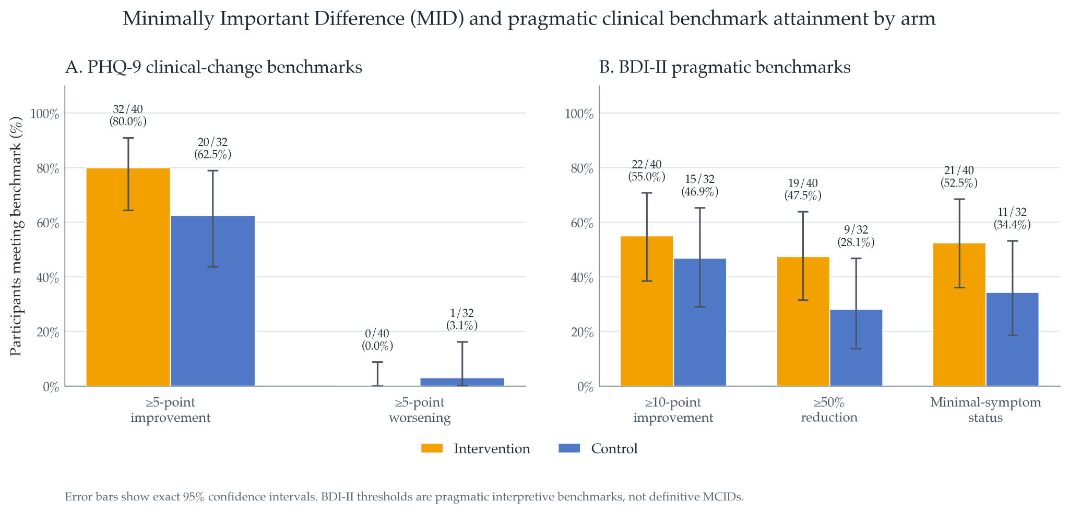
Figure S10.1. Minimally Important Difference (MID) and pragmatic clinical benchmark attainment by arm. Bars show the percentage of available-case WP2 participants meeting pre-specified or pragmatic clinical-change benchmarks at endpoint, separately for intervention and control arms. PHQ-9 benchmarks used a 5-point reduction for clinically meaningful improvement and a 5-point increase for clinically meaningful worsening. BDI-II benchmarks summarised at least 10-point improvement, at least 50% reduction from baseline, and minimal-symptom status, defined as endpoint BDI-II ≤13. Error bars show exact binomial 95% confidence intervals. These benchmark summaries are descriptive feasibility-trial estimates and are not interpreted as confirmatory evidence of efficacy.

Response and Remission Summaries
Response and remission outcomes were summarised descriptively by trial arm. For PHQ-9, response was defined as a reduction of at least 50% from baseline, and remission was defined as endpoint PHQ-9 <5. For BDI-II, response was defined as a reduction of at least 50% from baseline, and minimal-symptom status was defined as endpoint BDI-II <=13.
PHQ-9 response was observed in 29/40 intervention participants (72.5%; exact 95% CI: 56.1% to 85.4%) and 20/32 control participants (62.5%; exact 95% CI: 43.7% to 78.9%). PHQ-9 remission was observed in 25/40 intervention participants (62.5%; exact 95% CI: 45.8% to 77.3%) and 15/32 control participants (46.9%; exact 95% CI: 29.1% to 65.3%).
BDI-II response was observed in 19/40 intervention participants (47.5%; exact 95% CI: 31.5% to 63.9%) and 9/32 control participants (28.1%; exact 95% CI: 13.7% to 46.7%). BDI-II minimal-symptom status was observed in 21/40 intervention participants (52.5%; exact 95% CI: 36.1% to 68.5%) and 11/32 control participants (34.4%; exact 95% CI: 18.6% to 53.2%).
These binary outcomes are descriptive and should be interpreted as feasibility-trial estimates rather than confirmatory evidence of efficacy.
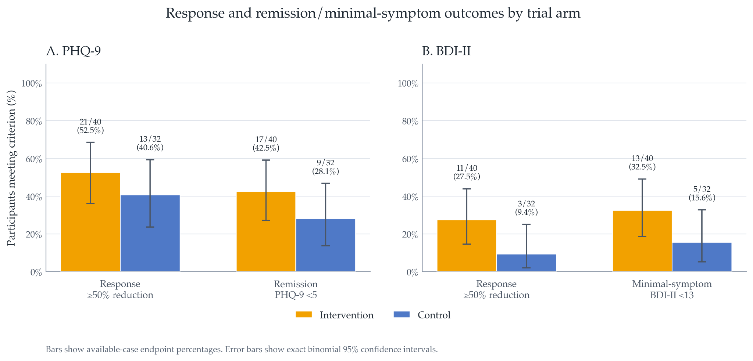Figure S10.2. Response and remission/minimal-symptom outcomes by trial arm. Bars show the percentage of available-case WP2 participants meeting each endpoint criterion, with exact binomial 95% confidence intervals. PHQ-9 response was defined as ≥50% reduction from baseline, and PHQ-9 remission as endpoint PHQ-9 <5. BDI-II response was defined as ≥50% reduction from baseline, and BDI-II minimal-symptom status as endpoint BDI-II ≤13. Labels above bars show n/N and percentage. Outcomes are reported descriptively and are not interpreted as confirmatory evidence of efficacy.

Confidence Intervals
All exploratory clinical summaries and contrasts were reported with 95% confidence intervals where applicable. For within-arm mean changes, confidence intervals were calculated using paired available-case data, or model-derived estimates where model-based summaries were reported. For between-arm contrasts, the primary descriptive contrast was the intervention-minus-control difference in endpoint-minus-baseline change. For symptom scales where lower scores indicate fewer symptoms, negative values favour greater reduction in the intervention arm. Where clinical benchmark summaries are described as ‘improvement,’ these are reported separately as binary descriptive summaries. Baseline-adjusted endpoint contrasts were also reported for core endpoint outcomes.
Exploratory clinical outcomes were summarised using paired available-case change scores from baseline to endpoint, with 95% confidence intervals. Positive between-arm contrasts indicate greater improvement in the intervention arm relative to control.
For PHQ-9, the Control arm showed a mean improvement of 5.91 points, 95% CI [3.57, 8.24] (n = 32), while the Intervention arm showed a mean improvement of 8.10 points, 95% CI [6.34, 9.86] (n = 40). The intervention-minus-control difference in improvement was 2.19 points, 95% CI [-0.68, 5.07], p = 0.132. In the baseline-adjusted endpoint model, the Intervention arm had a lower endpoint PHQ-9 score than Control by 2.43 points, 95% CI [-5.04, 0.19], p = 0.069; expressed in the improvement-favouring direction, this corresponds to a contrast of 2.43 points, 95% CI [-0.19, 5.04].
For BDI-II, the Control arm showed a mean improvement of 9.03 points, 95% CI [5.30, 12.76] (n = 32), while the Intervention arm showed a mean improvement of 13.85 points, 95% CI [9.86, 17.84] (n = 40). The intervention-minus-control difference in improvement was 4.82 points, 95% CI [-0.55, 10.18], p = 0.078. In the baseline-adjusted endpoint model, the Intervention arm had a lower endpoint BDI-II score than Control by 6.38 points, 95% CI [-10.91, -1.85], p = 0.006; expressed in the improvement-favouring direction, this corresponds to a contrast of 6.38 points, 95% CI [1.85, 10.91].
For BAI, the Control arm showed a mean improvement of 8.00 points, 95% CI [4.73, 11.27] (n = 32), while the Intervention arm showed a mean improvement of 9.45 points, 95% CI [6.31, 12.59] (n = 40). The intervention-minus-control difference in improvement was 1.45 points, 95% CI [-3.00, 5.90], p = 0.518.
For MADRS-S, the Control arm showed a mean improvement of 3.24 points, 95% CI [1.94, 4.55] (n = 32), while the Intervention arm showed a mean improvement of 4.55 points, 95% CI [3.20, 5.89] (n = 40). The intervention-minus-control difference in improvement was 1.30 points, 95% CI [-0.54, 3.14], p = 0.162.
For SPANE Positive, the Control arm changed by -4.75 points, 95% CI [-5.74, -3.76] (n = 32), while the Intervention arm changed by -5.50 points, 95% CI [-6.41, -4.59] (n = 40). The intervention-minus-control difference was -0.75 points, 95% CI [-2.07, 0.57], p = 0.260. For SPANE Negative, the Control arm improved by 1.44 points, 95% CI [0.41, 2.46] (n = 32), while the Intervention arm improved by 1.40 points, 95% CI [0.42, 2.38] (n = 40). The intervention-minus-control difference was -0.04 points, 95% CI [-1.43, 1.36], p = 0.957. For SPANE Balance, the Control arm changed by -3.31 points, 95% CI [-4.79, -1.83] (n = 32), while the Intervention arm changed by -4.10 points, 95% CI [-5.37, -2.83] (n = 40). The intervention-minus-control difference was -0.79 points, 95% CI [-2.71, 1.13], p = 0.415.
Overall, the exploratory clinical estimates were directionally consistent with larger symptom improvement in the Intervention arm for the core depressive-symptom outcomes, particularly BDI-II. However, except for the baseline-adjusted BDI-II endpoint contrast, between-arm confidence intervals included zero, and these analyses should be interpreted as estimation-focused and exploratory rather than confirmatory.

Sensitivity Checks
Sensitivity checks examined whether exploratory clinical-signal estimates were sensitive to plausible analytic decisions rather than to a single endpoint definition. The main available-case endpoint analyses were compared with repeated-measures models using all available session, SMS, and follow-up timepoints where applicable. Additional checks excluded participants with major protocol deviations, assessed whether conclusions changed when endpoint was defined as post-Session 4 versus the final available follow-up assessment, and compared unadjusted change-score contrasts with baseline-adjusted endpoint contrasts.
These analyses were interpreted descriptively. Their purpose was to assess whether the direction and approximate size of the exploratory clinical estimates, particularly for PHQ-9 and BDI-II, were stable across reasonable analytic choices. They were not used to make confirmatory efficacy claims.
Across sensitivity checks, the direction of the PHQ-9 and BDI-II intervention-minus-control estimates was broadly consistent with the primary exploratory endpoint analyses, although interval estimates remained wide.

S11. WP2 Acute Phenomenology, Expectancy, Masking, and Candidate Predictors

Target-Population Acute Phenomenology and Active-Comparator Separation
Scoring and Analysis Population
Post-session acute phenomenology was examined directly in the WP2 target population. The 6D-VHQ was scored across its six dimensions (Geometric Content, Semantic Content, Level of Detail, Vividness, Entropy, and Focality), with items 10, 11, 12, and 17 reverse-scored before calculating three-item dimension means on the original 1-5 scale. This is consistent with the scoring used for the interim bridge study. The 5-ASC was summarised for the arm-by-session analysis as the mean across the 42 administered items, retaining the original 0-100 item metric; the eleven 11-ASC factor means were additionally calculated for descriptive profile visualisation.
Repeated-session analyses used participant-session observations without visit imputation, consistent with the general WP2 available-case approach. Available post-session phenomenology data comprised 40, 39, 39, and 39 Intervention participants and 39, 35, 32, and 31 control participants at Sessions 1-4, respectively.

Arm-by-Session Phenomenology
Both conditions produced substantial acute subjective and visual phenomenology. On the 6D-VHQ, control-arm means were clearly above the scale floor across all four sessions, ranging from 4.18-4.36 for Geometric Content, 3.62-3.94 for Vividness, 3.09-3.40 for Entropy, 2.70-2.84 for Detail, 2.10-2.56 for Focality, and 1.53-2.06 for Semantic Content. Intervention-arm scores likewise showed substantial phenomenology, with particularly high Geometric Content and Vividness Ratings.
For the 42-item mean 11-ASC score, the pooled arm contrast was 3.03 points (95% CI -3.68 to 9.73, p = 0.371), providing no clear evidence of an overall between-arm difference averaged across sessions. There was, however, evidence that the 11-ASC trajectories differed over time, arm x session: F(3, 210.96) = 3.25, p = 0.023. None of the individual session-specific arm contrasts was statistically clear after correction across the four sessions, indicating that this interaction reflects the differing longitudinal profiles rather than a single decisive session-specific contrast.
For the 6D-VHQ, the pooled Intervention-minus-Control estimates were small and imprecise. Geometric Content, Δ = 0.21 (95% CI -0.07 to 0.50); Detail, Δ = 0.17 (-0.20 to 0.54); Vividness, Δ = 0.07 (-0.24 to 0.38); Focality, Δ (-0.11 to 0.64); Semantic Content, Δ = 0.16 (-0.26 to 0.58); and Entropy, Δ ≈ 0.00 (-0.39 to 0.38). None of the six pooled contrasts excluded zero, and none survived Holm correction across the six dimensions; see Supplementary Material workbook “WP2 Phenomenology by Arm/Session”.
There was nevertheless evidence that separation varied across sessions for Focality, F(3, 212.27) = 6.11, Holm-adjusted p = 0.003. This interaction was driven principally by Session 3, when Intervention participants reported greater Focality than Controls (Δ = 0.76, 95% CI 0.30 to 1.23); within-dimension Holm-adjusted p = 0.006). The Semantic Content interaction was nominally significant before multiplicity correction, F(3, 209.59) = 2.81, p = 0.41, but did not survive correction across the six 6D-VHQ dimensions (Holm-adjusted p = 0.203). Similarly, the Session-4 Semantic Content contrast (Δ = 0.61, 95% CI 0.08 to 1.13) did not survive correction across the four session-specific comparisons.
Geometric Content was greater in the Intervention arm at Session 1 (Δ = 0.45, 95% CI 0.10 to 0.80; within-dimension Holm-adjusted p = 0.047), but this difference attenuated thereafter and the overall Geometric Content arm x session interaction was not statistically clear. Detail, Vividness, and Entropy showed no clear pooled or longitudinal between-arm separation.

Comparison with the Interim Bridge-Study Calibration
The healthy within-participant bridge study had shown substantially larger Intervention-minus-Control differences for Geometric Content (1.14), Detail (1.05), Vividness (0.97), Focality (0.42), and Semantic Content (0.41), with no clear Entropy difference.
The direction of the WP2 pooled effects was broadly consistent with that bridge-study pattern; all five dimensions that previously showed positive separation again had positive Intervention-minus-Control point estimates. However, their magnitudes were markedly attenuated, and the 95% confidence intervals for all five pooled WP2 contrasts included zero. The particularly large bridge-study differences in Geometric Content, Detail, and Vividness were reduced from 1.14, 1.05, and 0.97 to approximately 0.21, 0.17, and 0.07 points, respectively.
Accordingly, the broad phenomenological separation demonstrated under healthy within-participant calibration was not reproduced at the group level in the parallel-group WP2 target sample. This does not imply an absence of phenomenological differences at every session. Session-1 Geometric Content and the longitudinal Focality pattern provide evidence of some condition-dependent separation. Rather, the intended manipulation did not produce the robust and generalised between-condition distinction observed in the bridge study.
Crucially, the WP2 Control condition itself produced substantial visual phenomenology and cannot be characterised as a near-inert phenomenological comparator. The WP2 randomised contrast should therefore be interpreted as comparing two active SLS configurations, rather than as estimating SLS against little or no visual phenomenology.

Caveats
An important qualification is that the interim and WP2 studies differed not only in population but also in the experiential context in which phenomenology was rated. The interim bridge study used a within-participant calibration design in which participants experienced both SLS configurations. Repeated exposure to both conditions therefore provided an internal experiential reference against which subsequent questionnaire ratings could be anchored. By contrast, WP2 used parallel-group allocation, and participants were necessarily condition-naive with respect to the alternative SLS configuration. Providing cross-condition experiential calibration before or during WP2 would have risked revealing the nature of the manipulation and undermining the intended allocation contrast. Consequently, absolute 6D-VHQ ratings in WP2 may reflect both the experience elicited by the assigned condition and individual differences in how participants interpreted and anchored the response scale in the absence of a within-person comparator.
This possibility was also consistent with piloting observations during sequence development, in which ratings obtained before participants had experienced the range of SLS phenomenology could appear high relative to ratings made after exposure to a more intense visual sequence. Such observations were not prospectively quantified and are therefore not treated as evidence in the present analysis, but they motivated caution in interpreting absolute between-group VHQ scores as direct equivalents of the within-participant bridge-study contrasts. In particular, the absence of a strong WP2 between-arm VHQ difference cannot distinguish between genuinely overlapping phenomenology and reduced measurement discrimination arising from condition-naive scale use.
The 11-ASC results provide complementary but not equivalent information. The 42-item mean 11-ASC score indexes a broad range of altered-state features rather than visual phenomenology specifically. Similar overall scores between conditions could therefore arise from different experiential compositions, and should not be interpreted as demonstrating phenomenological equivalence. Consistent with this, the descriptive 11-factor profiles and the significant arm-by-session interaction in the overall 11-ASC mean suggest that the temporal structure of altered experience differed between conditions even though the pooled mean-item contrast was not clearly different. The 6D-VHQ therefore remains the more direct measure of the visual-perceptual distinction targeted by the comparator manipulation, while the 11-ASC provides broader contextual characterisation of the acute state.
Taken together, the WP2 data therefore refine rather than invalidate the comparator-development findings. They show that both configurations were active experiential interventions in adults reporting depressive symptoms, while the magnitude and temporal stability of their phenomenological separation were less clear than under within-participant calibration. The findings identify target-population phenomenological discrimination, not simply physical stimulus differentiation, as a specific feasibility issue for subsequent trials. Future comparator validation should therefore assess the two configurations directly in the target population using a design that preserves masking while providing condition-neutral scale anchoring, and should prospectively distinguish visual-intensity measures from broader altered-state, relaxation, expectancy, and credibility measures.

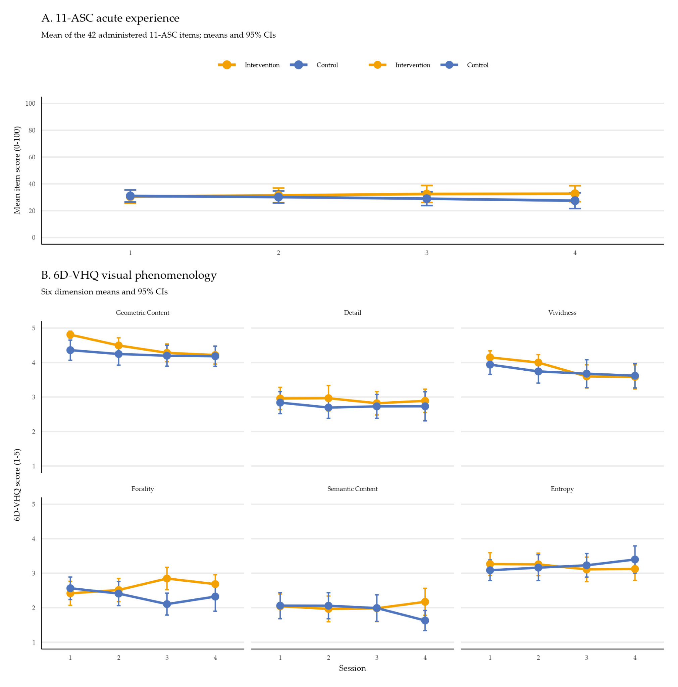Figure S11.1. WP2 acute phenomenology by arm and session.
Panel A shows the participant-session mean across the 42 administered 11-ASC items on the original 0-100 item metric. Panel B shows the six 6D-VHQ dimension means on the original 1-5 scale. Points indicate arm-specific means and error bars indicate 95% confidence intervals. Repeated-session summaries use available-case observations without imputation. Mixed-effects analyses corresponding to these trajectories are reported in the accompanying text.
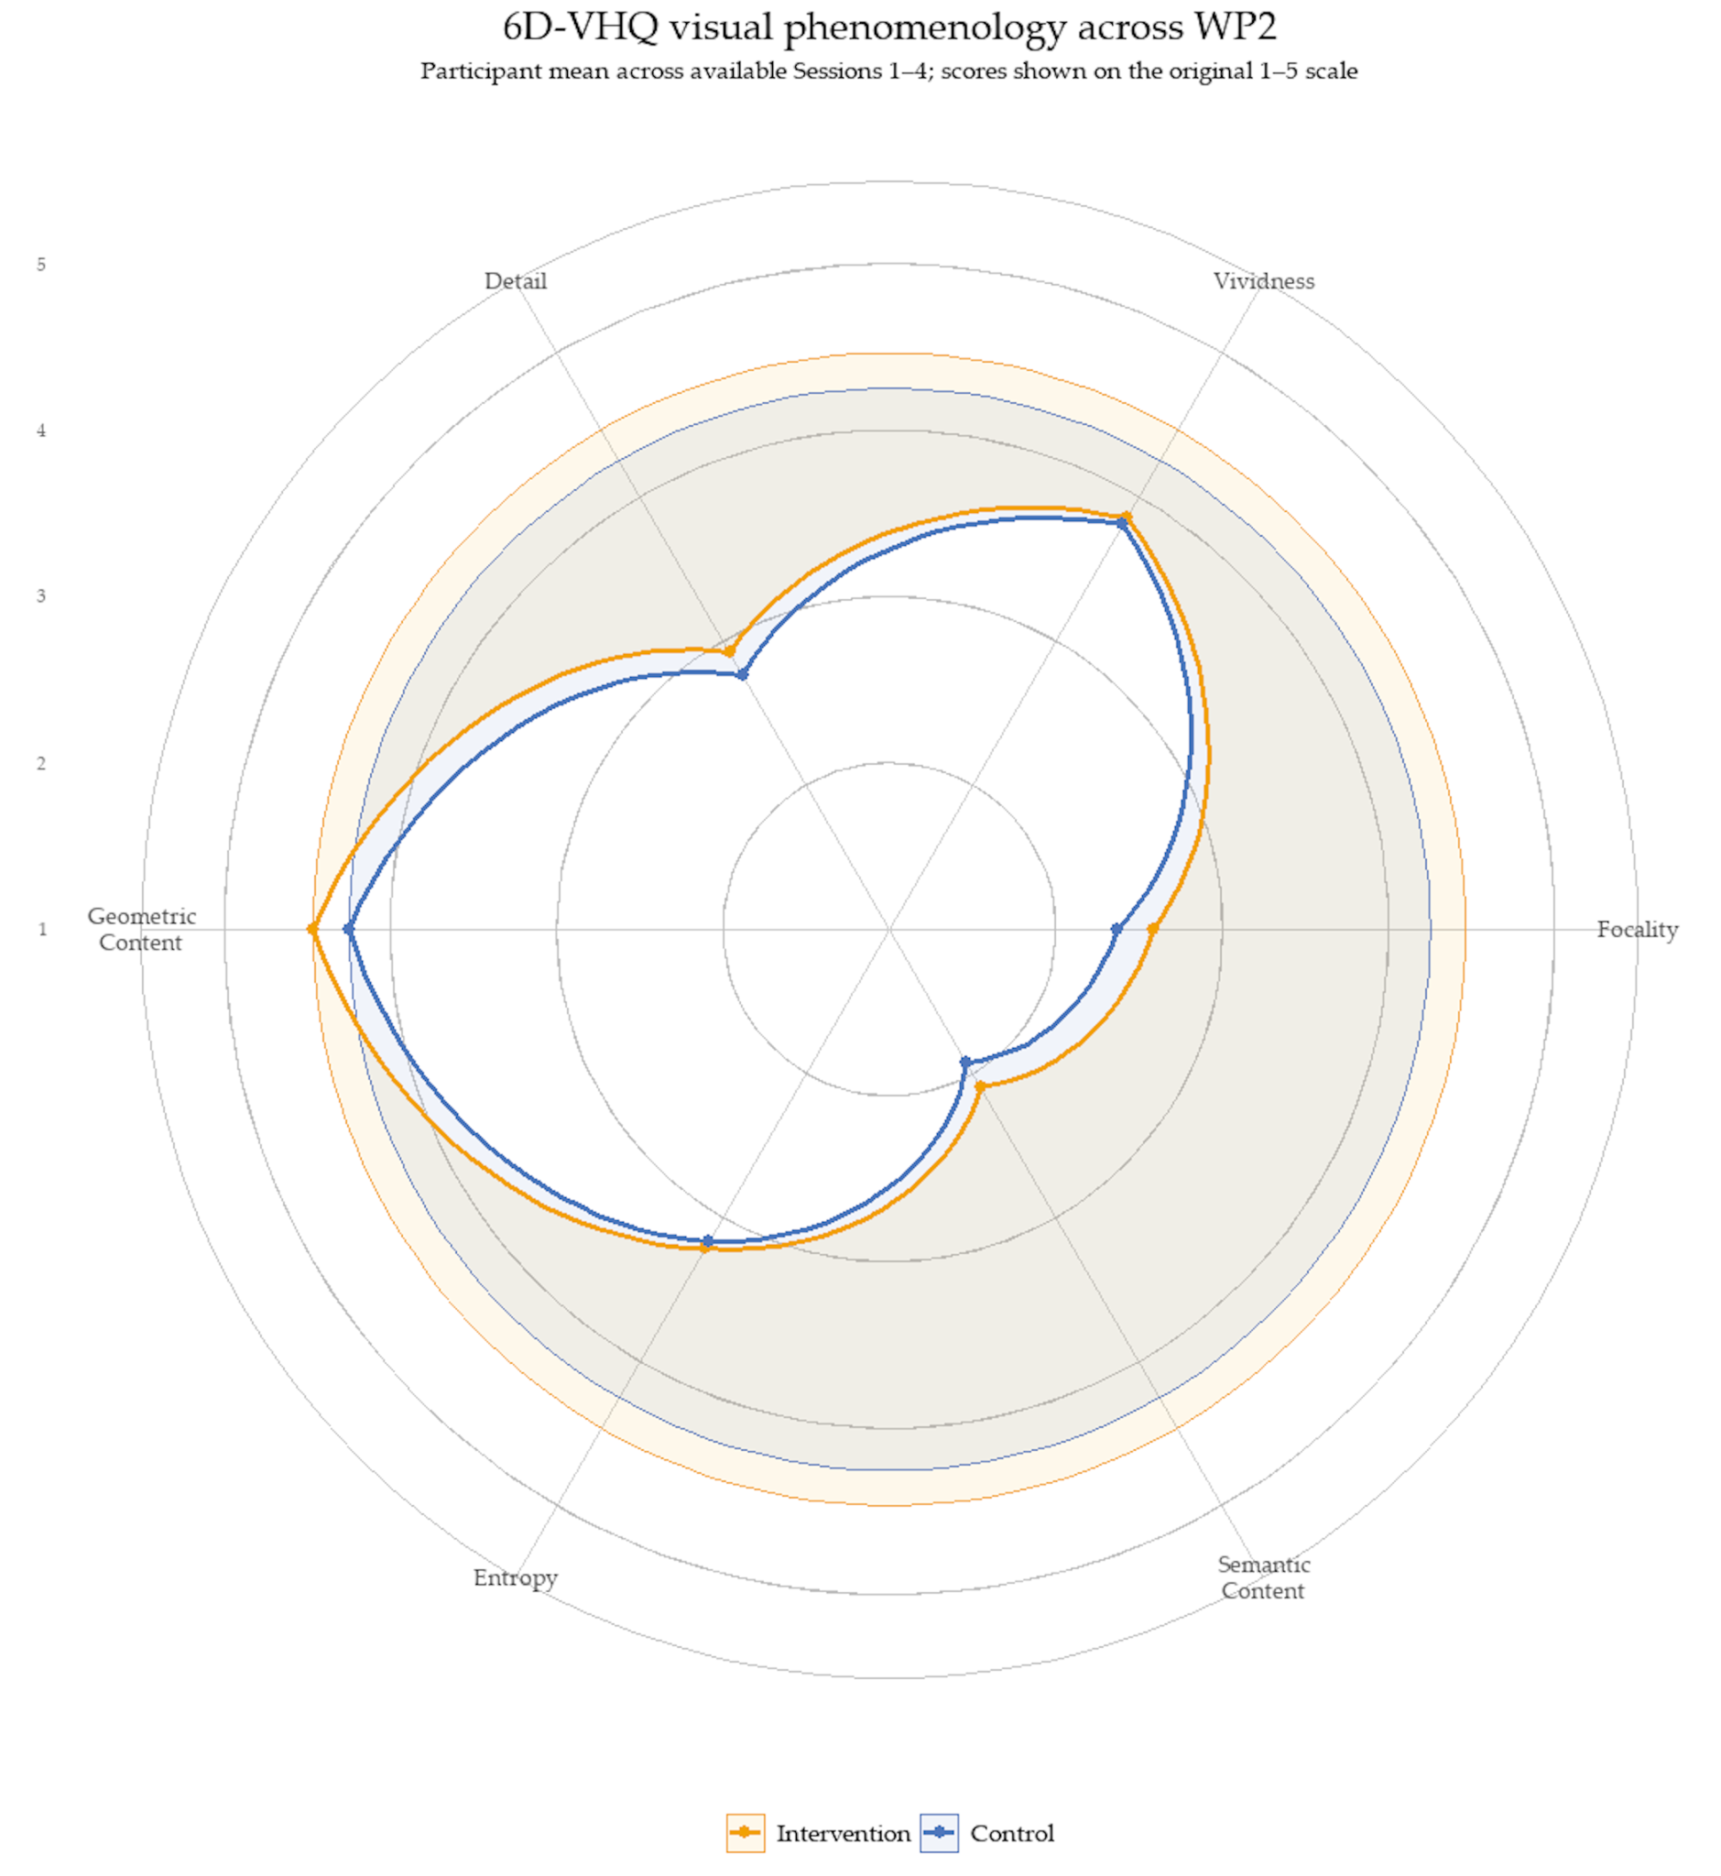
Figure S11.2. Four-session mean 6D-VHQ phenomenological profile by WP2 arm.
For descriptive visualisation, each participant’s score on each 6D-VHQ dimension was first averaged across available Sessions 1-4 and participant-level means were then averaged equally within arm. Axes show scores on the original 1-5 scale. The radar plot summarises the overall phenomenological profile and should be interpreted alongside the arm-by-session mixed-effects analyses in Figure S11.1.
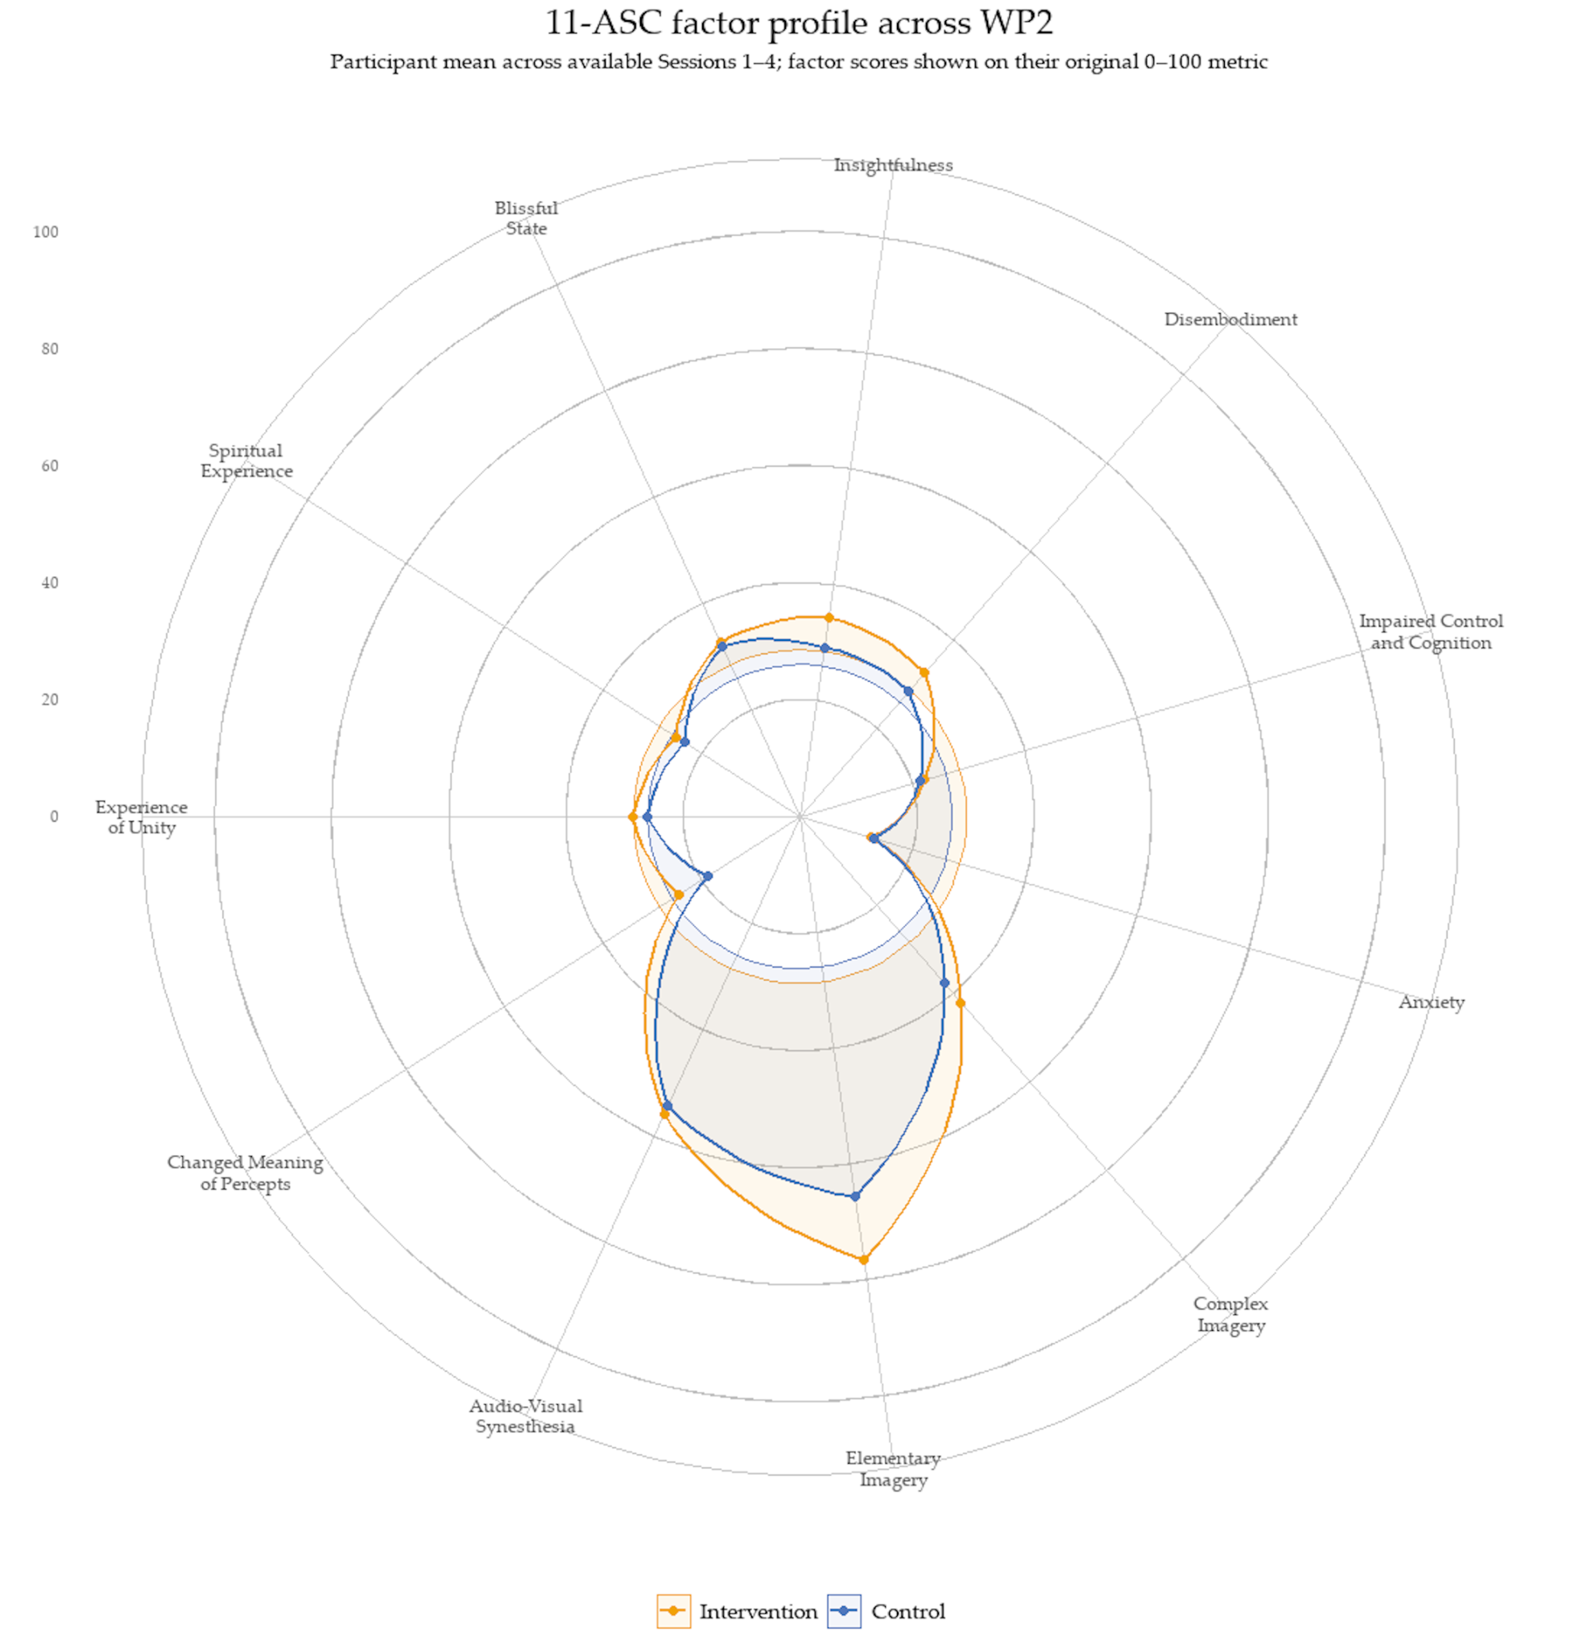
Figure S11.3. Four-session mean 11-ASC factor profile by WP2 arm.
For descriptive visualisation, each participant’s score on each of the eleven 11-ASC factors was first averaged across available Sessions 1-4 and participant-level means were then averaged equally within arm. Factor scores are shown on the original 0-100 item metric. The factor-level radar is descriptive and was not treated as a family of eleven confirmatory between-arm tests.

Exploratory 11-ASC Tertile and Continuous Candidate-Predictor Analyses
Exploratory analyses examined whether acute altered-state experience was associated with subsequent BDI-II outcome within each WP2 arm. Acute experience was indexed using the 42-item 11-ASC summary score and standardised within the available analysis sample. For descriptive visualisation, participants were divided into lower, middle, and upper tertiles separately within each trial arm. These tertiles were data-derived descriptive groups rather than prespecified or clinically meaningful categories and not used as confirmatory tests of treatment moderation.
Descriptively, BDI-II improvement differed across 11-ASC tertiles. In the Intervention arm, mean improvement was 6.73 points in the lower tertile, 15.80 points in the middle tertile, and 19.67 points in the upper tertile. In Control, corresponding improvements were 5.67, 10.57, and 10.00 points. Thus, the descriptive gradient was more monotonic in Intervention, whereas the Control pattern was non-monotonic; however, baseline BDI-II severity differed across some tertiles, meaning that these unadjusted subgroup patterns are potentially influenced by baseline severity and regression to the mean. They should therefore not be interpreted as evidence that stronger acute experience caused greater subsequent improvement.
The complementary continuous analyses retained acute experience as a continuous predictor and adjusted for baseline BDI-II and baseline treatment expectancy. Within Intervention, each 1-SD higher 11-ASC score was associated with a -2.29-point difference in post-treatment BDI-II (95% CI -5.10 to 0.51, p = 0.106). In Control, the corresponding estimate was -1.74 points (95% CI -6.20 to 2.72, p = 0.432). Both confidence intervals included zero.
Accordingly, the tertile analysis is retained only as a descriptive representation of a candidate predictor-outcome pattern. The baseline-adjusted continuous models provide the more informative exploratory analysis and remain imprecise. These findings do not establish moderation, meditation, dose-response, or mechanism and are included to inform hypotheses and analysis planning for a future adequately powered trial.
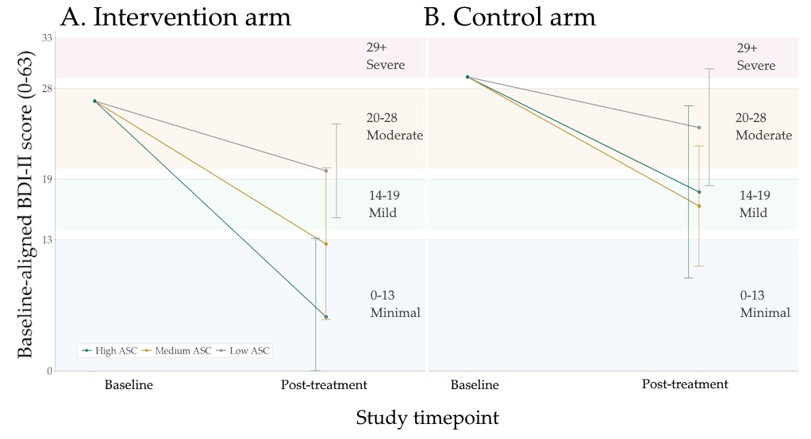
Figure S11.4. Descriptive baseline-aligned BDI-II improvement by 11-ASC acute-experience tertile. For visualisation only, plotted baselines were aligned to a common arm-specific mean and therefore do not display the observed baseline differences between tertiles. Observed baseline values are reported below. Because baseline BDI-II differed across tertiles, this display cannot establish a dose-response relationship and should be interpreted only as a descriptive representation of observed change. Baseline-adjusted continuous models are reported through S10.

TEX-Q/SETS Handling
Treatment expectancy was assessed at baseline using expectancy items available in the pre-Session 1 file. Baseline expectancy was indexed using a summed pre-treatment expectancy score derived from the available Session 1 expectancy items. This score was treated as a local expectancy composite of fifteen TEX-Q items rather than as a formal masking or treatment-guess measure.
Baseline treatment expectancy was summarised by trial arm before candidate-predictor analyses to assess whether expectancy differed meaningfully between arms before stimulation. The intervention arm had a mean summed expectancy score of 55.76 (SD = 23.06, n = 42), while the control arm had a mean score of 59.79 (SD = 19.75, n = 39). A Welch two-sample comparison gave p = 0.399, and a Wilcoxon rank-sum comparison gave p = 0.359. These descriptive checks did not suggest a clear baseline expectancy imbalance between arms. Expectancy analyses were therefore treated as exploratory candidate-predictor analyses rather than as evidence that expectancy was experimentally controlled or absent.

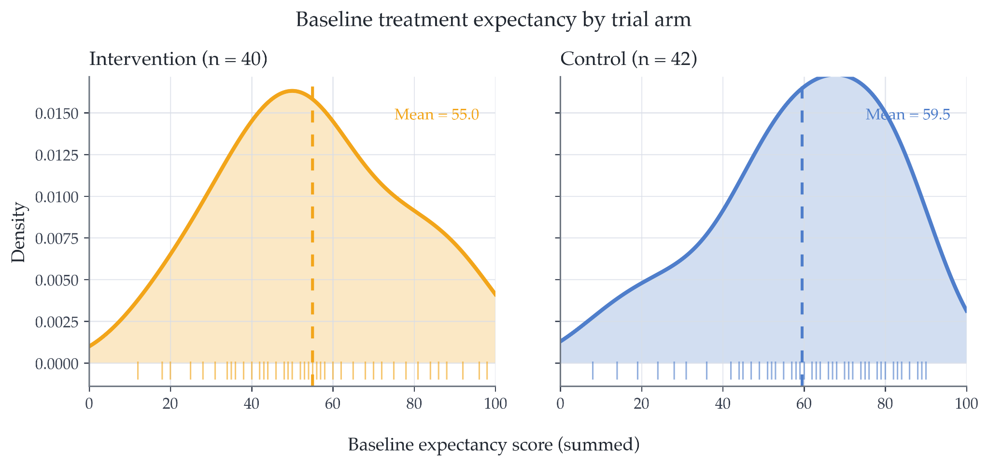
Figure S11.4. Baseline treatment expectancy by trial arm. Density plots show the distribution of summed session-1 pre-treatment expectancy scores for available WP2 participants in the intervention and low-phenomenology control arms. Rug marks show individual participant scores, and dashed vertical lines show arm-specific means. The figure is descriptive and is used to assess visual balance in baseline expectancy between arms.
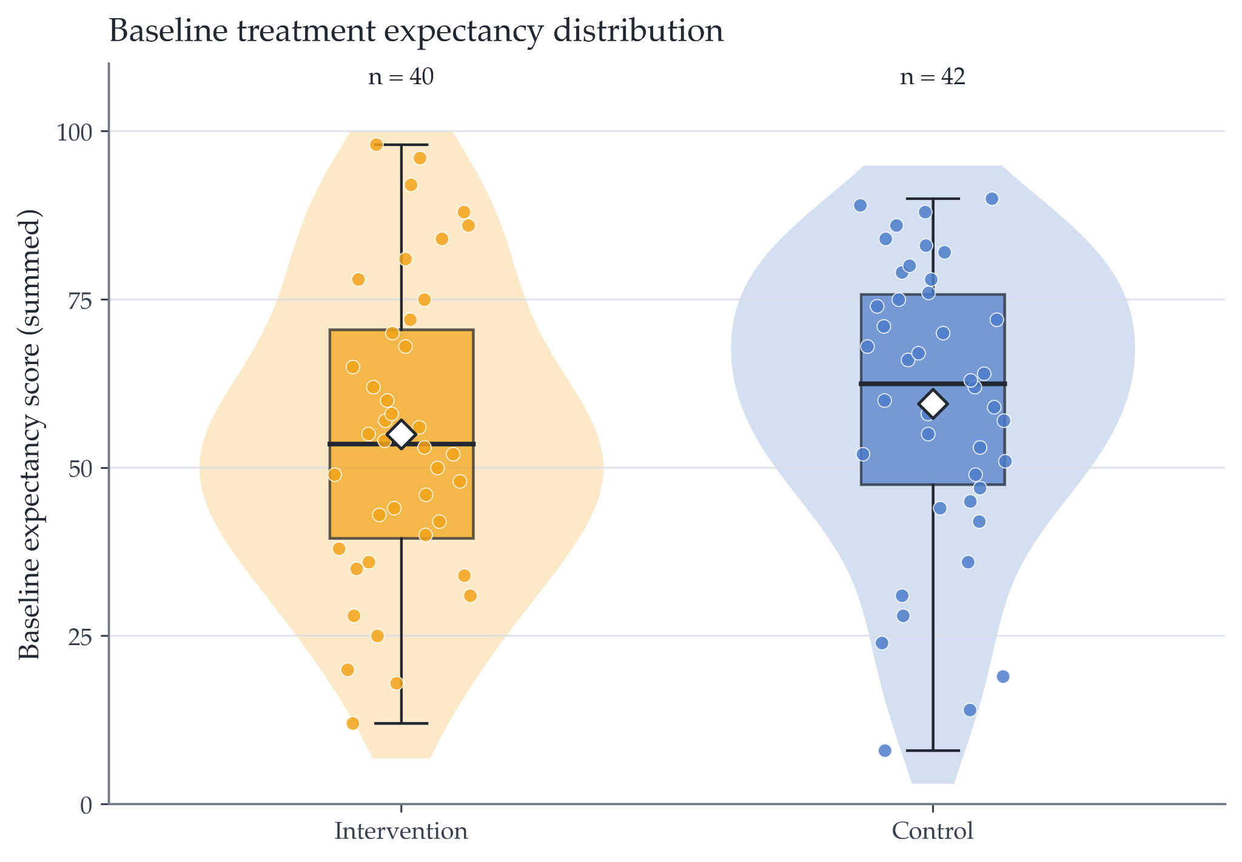
Figure S11.5. Baseline treatment expectancy distribution by trial arm. Violin plots show the distribution of summed session-1 pre-treatment expectancy scores for available WP2 participants in the intervention and low-phenomenology control arms. Embedded boxplots show the median and interquartile range, jittered points show individual participant scores, and white diamonds show arm-specific means. The figure is descriptive and is used to assess visual balance in baseline expectancy between arms.

Masking and Credibility Data
No formal masking or credibility outcome was available beyond expectancy-related measures and the use of masked sequence names for researcher-facing session administration. No formal treatment-guess item was collected. Expectancy analyses therefore assess baseline belief/expectancy and candidate-predictor relationships, but do not directly test whether participants correctly guessed their allocation. This limitation should be addressed in future trials by prospectively collecting participant and assessor allocation guesses, credibility ratings, and confidence in allocation guesses after each session or at endpoint.

Subgroup Split Definitions
Candidate-predictor analyses used tertile-based visualisations rather than median splits. For the manuscript Figure 6 analysis, acute subjective experience was indexed using total 11-ASC score. Total 11-ASC was standardised within the available Figure 6 analysis sample and divided into lower, middle, and upper tertiles within each trial arm. Tertiles were used only as descriptive visualisation groups and should not be interpreted as clinically meaningful categories.
The middle tertile was displayed descriptively, while the primary descriptive visual pattern was the difference in mean BDI-II improvement between the high and low total 11-ASC tertiles within each arm. For these descriptive visualisations, BDI-II improvement was calculated as baseline BDI-II minus post-Session-4 BDI-II, so positive values indicate greater symptom reduction. Because baseline BDI-II differed across some tertiles, Figure 6 used baseline-aligned trajectories: within each arm, the plotted baseline was set to a shared arm-specific mean baseline, and each tertile’s plotted post-treatment value reflected that tertile’s observed mean improvement from the shared baseline. These subgroup visualisations were arm-specific, exploratory, and intended to visualise candidate predictor–outcome patterns for future hypothesis generation, not to define responder subgroups or establish mechanism.

6D-VHQ / 11-ASC Candidate-Predictor Models

Acute subjective experience was examined as an exploratory candidate predictor of depressive-symptom improvement. Broader candidate-predictor checks considered post-stimulation Six-Dimensional Visual Hallucination Questionnaire (6D-VHQ) dimension scores and 11-factor Altered States of Consciousness (11-ASC) scores. These analyses estimated whether higher acute visual-phenomenology or altered-experience ratings were associated with greater improvement in depressive symptoms at endpoint.

The manuscript Figure 6 analysis focused specifically on total 11-ASC rather than 6D-VHQ. In the Figure 6 continuous models, total 11-ASC was z-scored within the available analysis sample and modelled separately within the Intervention and Control arms. The within-arm model form was:

post_treatment_BDI_II ~ baseline_BDI_II + total_ASC_z + expectancy_z

where total_ASC_z denotes z-scored total 11-ASC and expectancy_z denotes z-scored baseline treatment expectancy. Negative coefficients for total_ASC_z indicate lower post-treatment BDI-II scores per 1-SD higher total 11-ASC, conditional on baseline BDI-II and expectancy.

The broader exploratory candidate-predictor framework also considered models of the form:

improvement_score ~ predictor + arm + baseline_score

where predictor could be baseline expectancy, a 6D-VHQ dimension score, or an 11-ASC score; arm indexed intervention versus control allocation; and baseline_score adjusted for baseline symptom severity. In these broader improvement-score models, improvement was defined as baseline score minus endpoint score, so positive values indicate greater symptom reduction. These pooled models were treated as descriptive sensitivity checks and should not be interpreted as the primary Figure 6 analysis.

Where repeated-measures outcome data were used, the exploratory mixed-effects model was:

outcome_score ~ timepoint * arm + predictor + predictor:timepoint + baseline_score + (1 | participant)

with participant-level random intercepts. These models were used descriptively to assess whether candidate predictors tracked symptom trajectories, not to establish mechanism. Where predictors and endpoint outcomes were measured close together in time, results were interpreted as endpoint-adjacent associations rather than evidence of prospective prediction or mediation. Any mechanistic interpretation would require a future trial with prespecified temporal ordering, treatment-arm-adjusted or within-arm models, formal masking and expectancy measurement, and stronger control of confounding. Further details can be found in the attached Excel workbook, tab “Figure 6 ASC Predictors”.

Multiple-Comparison Caution
All expectancy and candidate-predictor analyses were exploratory and involved multiple correlated outcomes and predictors. No formal multiplicity correction was applied. P-values were therefore interpreted descriptively and were not used as confirmatory evidence of mechanism. Interpretation emphasised effect-size direction, confidence intervals, consistency across related measures, and plausibility for future hypothesis generation. No single candidate-predictor result should be interpreted as definitive without replication in a larger trial.

S12. Figure and Analysis Reproducibility

Data Files
All anonymisable data, music, supplementary material, and analysis scripts can be found at the designated github repository, https://github.com/dannynacker/SLSD.

Data-Access Statement
De-identified data and analysis scripts required to reproduce the figures and supplementary tables will be made available in an open repository upon publication, subject to ethical and data-protection restrictions. Files containing direct identifiers, contact details, calendar booking metadata, or mappings between participant IDs and personal information will not be shared.
The repository will include figure-ready analysis datasets, statistical notebooks or scripts, and the accompanying supplementary Excel workbook containing extended tables and model outputs. Where data cannot be shared at participant level, derived or aggregate datasets sufficient to reproduce reported figures and tables will be provided where ethically permissible.

Code/Software Versions
Final manuscript figures, supplementary tables, workbook outputs, and narrative summaries were generated in R using a single integrated analysis environment. The core figure-generation workflow used tidyverse, lubridate, showtext, sysfonts, patchwork, and scales, with grid and stats used from base R. Additional table-generation, workbook-export, and data-cleaning sections used readr, stringr, openxlsx, janitor, and glue, with readxl used where supplementary workbook values were read back into R for figure-generation or reconciliation checks.
The R environment generated figure-ready datasets, audit files, manuscript figures, supplementary tables, narrative text outputs, and Excel workbook tabs from the staged WP1, interim, and WP2 source files. Exact R and package versions will be documented using the final R session information deposited with the analysis scripts.
Python/Google Colab notebooks were used during earlier development stages for SLS sequence construction, interim sequence-condensation checks, WP2 stratification, allocation monitoring, and safety/adherence monitoring. The WP2 stratification workflow used Python data-handling and deterministic randomisation logic, including pandas, Python’s built-in random module, hashlib-based blinded sequence-code generation, and a fixed seed for reproducibility. Final manuscript-facing statistical summaries and figures were generated from the R analysis environment unless otherwise specified.
The final repository will include the R session information and package versions used to generate the submitted figures and supplementary tables.

Figure-Generation Scripts
Figure-generation scripts were organised by manuscript figure. Figure 1 used WP1, interim, and WP2 flow files to generate a programme-level CONSORT-style diagram. Figure 2 used WP1 session-feedback data for safety and tolerability summaries. Figure 3 used the interim analysed file, including 6D-VHQ items and block-level ranking variables. Figure 4 used WP2 assignment, pre-session, and post-session files to summarise feasibility and repeated-session tolerability. Figure 5 used WP2 clinical outcome files to plot exploratory symptom trajectories. Figure 6 used baseline expectancy, acute-experience, and endpoint symptom data for candidate-predictor analyses.

Preprints and Unpublished Material Used
Developmental scripts, internal progress reports, interim presentation materials, and preprint-stage outputs were used to reconstruct the intervention-development history, analysis decisions, and study workflow. These materials were not treated as external evidence for efficacy. They were used only to document the provenance of the staged programme, sequence construction, internal monitoring procedures, and reproducibility of the final manuscript analyses.

